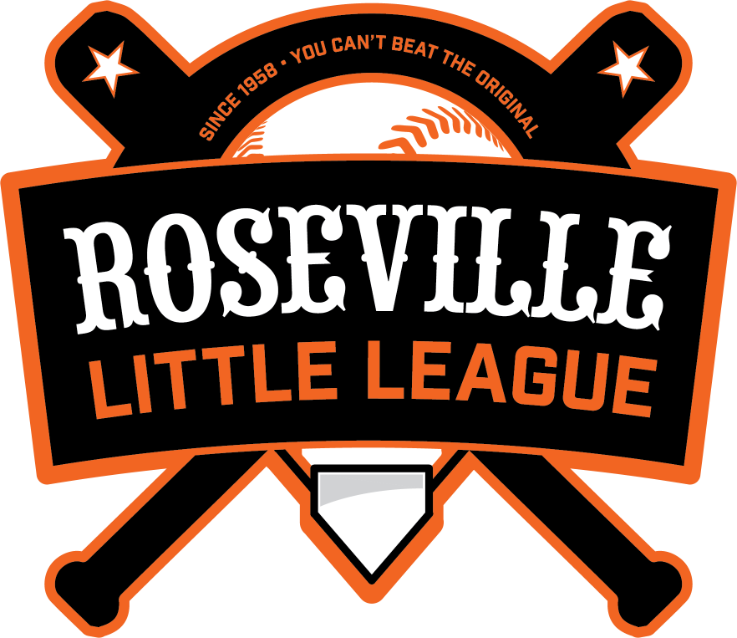

2024
Roseville Little League Safety Manual
League ID: 405-54-09

EMERGENCY CONTACT NUMBERS
MEDICAL/FIRE/POLICE EMERGENCY
DIAL – 911

Roseville Police – Non-Emergency (916)774-5000
Electrical Emergency: Roseville Electric (916)797-6937

2024 RWLL Safety Officer Kellie Allen (916)206-2852
(contact to report injuries)

2024 RWLL President
Pete Godtfredsen (916)276-5150

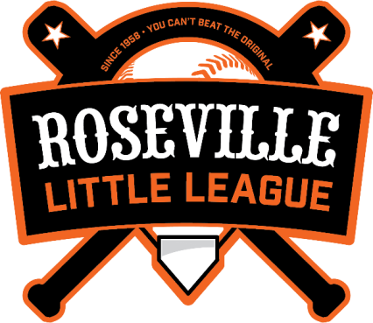

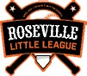
2024 BOARD OF DIRECTORS

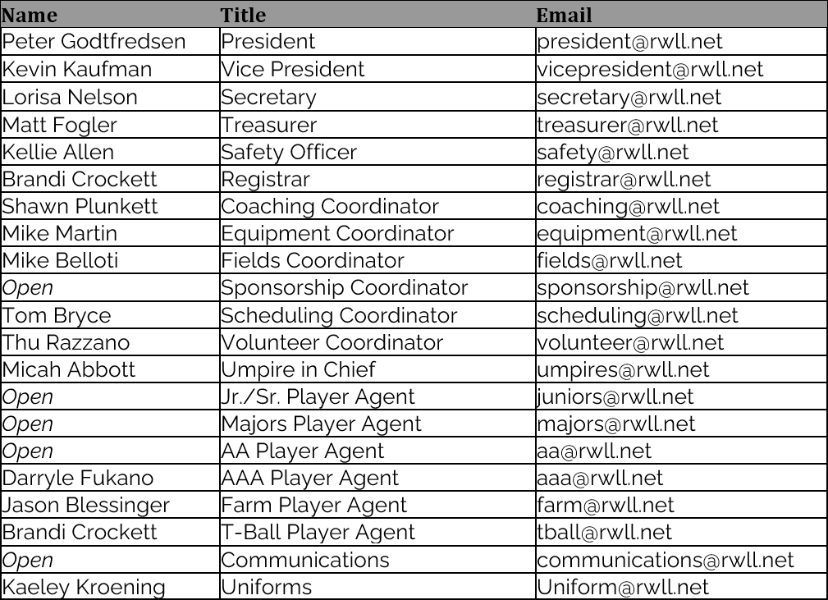

Roseville Little League| www.rosevillell.org PO Box 224, Roseville, CA 95678

INTRODUCTION

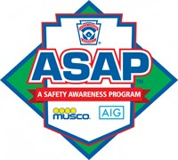
ASAP - What is it? In 1995, ASAP (A Safety Awareness Program) was introduced with the goal of re-emphasizing the position of Safety Officer “to create awareness, through education and information, of opportunities to provide a safer environment for kids and all participants of Little League Baseball ''. This manual is offered as too; to place some important information at manager’s and coach's fingertips.

Safety Officer: Local League Role
The Safety Officer is responsible for creating awareness and educating the league on the opportunities to provide a safer environment for children and all participants of Roseville Little League. The Safety Officer will prepare a safety manual each year for the league and make sure that the manual is used. A Safety Awareness Program (ASAP) will be prepared and submitted to Little League International each year.

Protecting children and everyone in the league is the focus. Through the work of the league Safety Officer, creation of a safe environment for Roseville Little League participants can be established and sustained.

The RLL Safety Manual will be posted on the Roseville Little League Baseball website under RLL Rules/Regulations/Forms. A printed copy will be placed in each field equipment box, in the snack bar at Richard’s Field and every team manager will be given a copy in their team binders. All safety questions or concerns should be directed to the league safety officer, Kellie Allen, at Safety@rwll.net.

Roseville Little League 2024 Safety Officer: Kellie Allen safety@rwll.net
916-206-2852

Roseville Little League Safety Code

Little League rules, the RLL Safety Plan, and the following Little League Safety Code, as adapted from the Little League Rulebook, will be enforced at all league activities:

- Responsibility for safety procedures should be that of an adult member of the local league.
- Arrangements should be made in advance of all games and practices for emergency medical services.
- Managers, coaches, and umpires should have some training in first-aid. First-Aid Kit should be available at the field.
- No games or practice should be held when weather or field conditions are not good, particularly when lighting is inadequate.
- Play area should be inspected frequently for holes, damage, glass, and other foreign objects.
- Dugouts and bat racks should be positioned behind screens.
- Only players, managers, coaches, and umpires are permitted on the playing field during play and practice sessions.
- Responsibility for keeping bats and loose equipment off the field of play should be that of a regular player assigned for this purpose.
- Procedure should be established for retrieving foul balls batted out of the playing area.
- During practice sessions and games, all players should be alert and watching the batter on each pitch.
- During warm up drills, players should be spaced so that no one is endangered by errant balls.
- Equipment should be inspected regularly. Make sure it fits properly.
- Pitching machines, if used, must be in good working order (including extension cords, outlets, etc.) and must be operated only by adult managers and coaches.
- Batters must wear protective NOCSAE helmets during practice, as well as during games.
- Catchers must wear catcher’s helmet (with face mask and throat guard), chest protector, and shin guards. Male catchers must wear a protective supporter and cup at all times.
- Except when runner is returning to a base, head first slides are not permitted. This applies only to Little League (Majors), Minor League, and Tee Ball.
- During sliding practice bases should not be strapped down.
- At no time should “horse play” be permitted on the playing field.
- Parents of players who wear glasses should be encouraged to provide “Safety Glasses.”
- Players must not wear watches, rings, pins, jewelry, hard cosmetic, or hard decorative items.
- Catchers must wear catcher’s helmet, face mask, and throat guard in warming up pitchers. This applies between innings and in bullpen practice. Skull caps are not permitted.
- Batting/catcher’s helmets should not be painted unless approved by the manufacturer.
- Regulations prohibit on-deck batters. This means no player should handle a bat, even while in an enclosure, until it is his/her time at bat. This applies only to Little League (Majors), Minor League, and Tee Ball.
- Players who are ejected, ill, or injured should remain under supervision until released to the parent or guardian.

Managers/Coaches Clinic
All Mangers and Coaches are invited to attend RLL’s Coaches Clinic. This year’s clinic is tentatively scheduled to be held at Richard’s field on Saturday, February 24, 2024 from 10:00am-11:30am.

FREE Big Al Baseball Training for managers, coaches and parents:
Roseville Little League is excited to secure memberships to Big Al’s online Programs for all the Managers, Coaches and Parents in our league for 2024!
Please visit the Roseville Little League website’s home page for information on creating your account so you can take advantage of all the amazing videos Big Al has to help your player’s baseball skills grow all season long.

First Aid/Safety Training
In addition to the Coaches Clinics, RLL managers and coaches must attend review the District 54 Safety Training video which will be available on the District 54 website in February 2024.

All managers, coaches, board members and adult umpires are required to complete the following safety trainings (junior umpires are strongly encouraged to complete):

- Online Concussion Training, through CDC Heads Up*
  - https://www.cdc.gov/headsup/youthsports/training/index.html
- Sudden Cardiac Arrest (SCA) Prevention Training, via Eric Paredes Save a Life Foundation*
  - https://epsavealife.org/sca-prevention-training/
- Child Protection Program Training (through SafeSport), Abuse Awareness for Adults*
  - https://www.littleleague.org/player-safety/child-protection-program/safesport- resourcesparents/
- JDP Background checks for all volunteers

* Certificates must be from a training completed within the current Little League year (October 1, 2023 though September 30, 2024) to be valid

Certificates of completion will need to be provided to the RLL Safety Officer by email at Safety@rwll.net prior to your first practice.

First Aid Do’s and Do not’s
DO…
- Reassure a child who is injured, sick, frightened, or lost.
- Ask permission before providing first aid.
- Know your limitations.
- Managers, carry with you or know the location of a first aid kit to all practices and games.
- Managers, have all player medical release forms with you at all practices and games.
- Always have a cell phone available at all practices and games.
- Report hazardous conditions to the Safety Officer or other board member immediately.

DO NOT…
- Administer any medications.
- Apply ice packs directly to skin. Wrap in a towel or apply over clothing.
- Provide food or beverages other than water.
- Be afraid to ask for help.
- Leave an unattended child at a practice or game.
- Hesitate to report any present or potential safety hazards to the Safety Officer or other board
- member.

Managers and coaches need to be aware if any players on their team any medical conditions/allergies and ensure those players bring any relevant equipment with them to team functions (i.e., inhalers, epi pens, etc.), including practices and games.

COMMON INJURIES

Impact Injuries – Object (likely ball or bat) striking player
- Typically ice and monitor
- Look for: obvious deformity (if extremity, compare with uninjured side), crepitus, swelling, bruising, hematoma, fracture/sprain/dislocation
- Immobilize above and below the joint (if applicable)
- The more sets of hands, the better
- Check for circulation before immobilizing
- Splint if possible (cardboard, wood, pillow, bulky clothing, etc.)
- Ice pack at injury site (not directly on skin)

Contusions (Bruises)
- It is the result of a direct blow or an impact, such as a fall.
- Rest the bruised area, if possible.
- Ice the bruise with an ice pack wrapped in a towel (do not apply directly to skin). Leave it in place for 10 to 20 minutes. Repeat several times a day for a day or two as needed.
- Compress the bruised area if it is swelling, using an elastic bandage. Don't make it too tight.
- Elevate the injured area.

Abrasions (“Raspberries”)
- Always use universal precautions when caring for wounds (Use disposable gloves, eye protection, mouth shield, etc., immediately wash hands or other skin surfaces with soap and water if contaminated with blood, clean all surfaces and equipment contaminated with blood).
- Rinse and clean the abrasion. Hold the affected area under lukewarm tap water for a couple of minutes. Do not aggressively scrub the wound. Attempt to gently remove any dirt or other particles.
- Apply a thin layer of petroleum jelly or antibiotic ointment. This will help keep the affected area moist and prevent infection. If you notice the formation of a rash or redness due to antibiotic ointment use, suspend use of the ointment.
- Protect and cover the abrasion. Use a clean bandage or a piece of gauze with tape. This helps keep the wound clean, prevents bacteria from infecting the area and helps keep the wound from reopening. It also keeps the area moist to help with healing.
- Follow Little League Baseball Appendix C – Communicable Disease Procedures: “An athlete who is bleeding, has an open wound, has any amount of blood on his/her uniform, or has blood on his/her person, shall be directed to leave the activity (game or practice) until the bleeding is stopped, the wound is covered, the uniform and/or body is appropriately cleaned, and/or the uniform is changed before returning to activity.”

Basic Bandaging
Most minor injuries will only require band-aids; in the event of harder to control bleeding:
- Direct pressure
- Elevate (if an extremity injury)
Note: don't keep removing the bandage to check to see if bleeding is controlled, you're inhibiting the clotting process; add bandages on top if necessary

Bloody Nose
- To control a nosebleed, have the player pinch the soft part of the nose just below the bony ridge, sit and lean forward slightly while breathing through their mouth. Pinching the nose will help the blood clot.
- It could take 5-15 minutes of continuous pressure for the bleeding to stop. If the nosebleed has not stopped after 15 minutes, call 911.
- Do not ask the player to lean back. The blood could get into the windpipe and block their airway or go into their stomach and cause the person to vomit. There is no evidence to support using ice packs on the back of the neck to stop bleeding from the nose.

Heat Related Illness
Those who are at higher risk for Heat Related Illness include very old/young, overweight, immune compromised individuals
- Heat Cramps
  - Signs and Symptoms: cramps (usually in fingers, arms, legs, or abdomen), warm/moist skin, weakness
  - Treatment: move them to a cool environment (shade, AC), drink cool water/sports drinks, massage the muscles, apply moist towel to muscles
- Heat Exhaustion
  - Signs and Symptoms: excessive sweating, cool skin, fatigue, dizziness, cramps, nausea, headache, anxiety, rapid RR
  - Treatment: fanning/misting, move them to a cool environment (shade, AC), lie them flat, drink cool water/sports drinks, remove (some) clothing as appropriate
- Heat Stroke (true emergency)
- Signs and Symptoms: hot/dry/flushed skin (lost the ability to sweat), altered level of consciousness, nausea/vomiting, rapid heart rate and respiratory rate, headache, seizure
- Treatment: Call 911, move them to a cool environment (shade, AC), remove clothes as appropriate, cold packs to neck/groin/armpits, drink cool water/sports drinks if able

Dental Injuries
- Control the bleeding in the mouth by gently biting on a towel. This will also help stabilize the tooth.
- If the tooth is broken or knocked out completely, first find the tooth or broken piece, then rinse it and store in milk or inside the cheek for transport to the dental office.
- IMMEDIATELY transport the player and the tooth to the dentist.

Anaphylaxis / Allergic reactions
- Some people/players may have serious allergic reactions to things like bees or peanuts.
- An allergic reaction can range from mild to very severe.
  - Those with a mild to moderate allergic reactions may develop a skin rash, stuffy nose, or red, watery eyes
  - Signs of anaphylaxis (a severe, life threatening allergic reaction) include any skin reaction (hives itchiness or flushing), swelling of the face, neck, tongue or lips, trouble breathing, signs and symptoms of shock, and nausea, vomiting, cramping or diarrhea.
- If you suspect a player is having anaphylaxis (a severe, life threatening allergic reaction), help them administer an EpiPen if one is on hand and call 9-1-1. The longer you wait to administer an EpiPen, the harder it is to stop an anaphylaxis reaction.

Concussion protocol
The State of California requires all coaches/managers and administrators (board members and umpires) of youth sports to complete concussion training annually. RLL requires manager/coaches, umpires and the Board of Directors to complete the Heads Up Concussion In Youth Sports training provided by the Centers for Disease Control (CDC) and successfully pass the concussion evaluation quiz. Successful completion of this training is required every year. The course can be accessed online at:
https://www.cdc.gov/headsup/youthsports/training/index/html
RLL provides all registrants with the CDC Heads Up Concussion Information Sheet and requires players and parents/guardians to complete the concussion information acknowledgement form.
A concussion is an injury to the brain resulting from a direct blow to the head or a direct blow to the body with transmission of force to the head. Common symptoms of concussion in adolescents are headache, dizziness, fogginess, unsteadiness and possibly nausea, vomiting or vision changes. If a player is suspected to have sustained a concussion injury, they should be removed from play and not allowed to return that day. When in doubt, sit them out.
After a player is removed from the field of play due to a suspected concussion, the decision about when to return to the field can only be made, per California law, by a health care professional qualified to make such a decision. The California Interscholastic Federation (CIF) specifies that this professional must be a physician (M.D. or D.O.). Therefore, RLL requires a written doctor’s note be submitted to the manager AND Safety Officer clearing the player before allowing a player to return to practice/play.

Sudden Cardiac Arrest (SCA) protocol
The State of California requires all coaches/managers and administrators (board members and umpires) of youth sports to complete sudden cardiac arrest (SCA) prevention training annually. EDHLL requires manager/coaches, umpires and the Board of Directors to complete SCA prevention training through the Eric Paredes Save A Life Foundation. Successful completion of this training is required every year. The course can be accessed online at:
https://epsavealife.org/sca-prevention-training/
RLL provides all registrants with the Eric Paredes Save A Life Foundation’s SCA Fact Sheet for Parents & Student Athletes and requires players and parents/guardians to read and sign the SCA information acknowledgement form.
Sudden Cardiac Arrest (SCA) is not the same as a heart attack. It is caused by a malfunction in the heart’s electrical system or structure due to an abnormality the person was born with or inherited, or it can develop as they grow. Players, parents/guardians, managers, coaches and adult volunteers should all be familiar with the following symptoms. If a player has any of these symptoms, they should tell an adult and see their physician right away:
- Fainting or seizure, especially during or right after exercise.
- Fainting repeatedly or with excitement or startle.
- Racing heart, palpitations, or irregular heartbeat.
- Dizziness or lightheadedness.
- Chest pain or discomfort with exercise.
- Excessive shortness of breath during exercise.
- Excessive, unexpected fatigue during or after exercise.

In the event of a possible cardiac arrest, follow the cardiac chain of survival:
- Call 9-1-1 and immediately begin CPR. Immediate and continuous application of CPR can
- triple the chance of survival.
- Find and apply an AED, if available.
- Continue CPR (and AED use, if available) until emergency medical services arrive.

Reporting Injuries
All ACCIDENTS MUST BE REPORTED TO THE RLL SAFETY OFFICER WITHIN 24 HOURS OF THE INCIDENT!
Accident Reporting Procedures:

What to report
An incident that causes any player, coach, manager, umpire, or
volunteer to receive medical treatment and/or first aid must be reported to the Safety Officer. This includes even passive treatments such as the evaluation and diagnosis of the extent of any injury or periods of rest.

When to report:
All such incidents described above must be reported to the Safety Officer within 24 hours of the incident. Roseville Little League’s Safety Officer contact info for the 2024 season is:
Kellie Allen (916)206-2852
Safety@rwll.net

How to Report:
Managers must inform the following people:
- Parent
- Player Agent
- Safety Officer

Managers are responsible for notifying the RLL Safety Officer of any injury or near miss via the RLL Injury Reporting Form. This is a Google form, not the Incident/Injury Tracking Report form. The Google form will collect basic information about the person involved and the incident:
- Manager’s name, phone number and email address.
- Incident date, time, and location.
- The injured person’s age, phone number.
- Brief description of the injury (or near miss).

Upon completion of the form, the information is sent directly to the Safety Officer. The RLL Injury Reporting Form may be accessed one of several different ways:
  - Using a mobile phone, scan the QR code found on the injury reporting tags attached to all first aid kits (located in the equipment storage boxes at all RLL fields) and the concession stand at Richard’s Field.
  - The QR code can also be found on injury reporting tags attached to all equipment bags and in the front pocket of each manager’s binder.
  - A link to the form is located on the RLL website under the Rules/Regulations/Forms page: https://www.rosevillell.org/Default.aspx?tabid=2736368

Within 24 hours of receiving the RLL Injury Reporting Form, the Safety Officer will contact the player's parent/guardian, or the adult involved, complete the official Incident/Injury Tracking Report form, determine if further action is needed (such as quarantine in the case of COVID-19, physician's note for return to play, etc.) and communicate the results of this conversation back to the reporting team manager. The Safety Officer will send a copy of the Incident/Injury Tracking Report form to the District 54 Safety Officer, per the district safety plan, and maintain the original on file.

If an injury/accident sustained during a Little League activity required professional medical attention, parents/guardians of the injured player are required to complete a copy of the Little League Accident Notification form (See Appendix G). This form must be completed by parents/guardians (if claimant is under 19 years of age) and a league official (the Safety Officer) and forwarded to Little League Headquarters within 20 days of the accident.

Any player who is removed from play for a suspected concussion, who requires professional services for an injury, or who is out of play for 7 days or more due to an injury must present a written clearance note from a physician to the Safety Officer to return to practice or games.

The RLL Safety Officer provides a monthly safety and injury report to the Board of Directors. Collective injury information is de-identified and analyzed for patterns and/or issues that require corrective measures and presented to the board for discussion and implementation of appropriate actions to prevent future issues. Similarly, the District 54 Safety Officer presents collected and de-identified injury information to the district staff and league presidents at their monthly meetings for similar action.

Volunteers/Background Checks

Managers, coaches, board members, and any other persons, volunteers or hired workers, who provide regular service to Roseville Little League and/or have repetitive access to or contact with players or teams must complete an annual background check, as required by Little League (*see below). A volunteer application form as well as provide a government-issued photo identification card for ID verification must be completed as part of this process.

Anyone refusing to fill out a Volunteer Application is ineligible to be a league member.

*Little League International requires all leagues and districts in the United States to conduct an annual background check, including a nationwide criminal search and a search of the National Sex Offender Registry. Little League's preferred provider, J.D Palatine, has a Criminal File database that contains more than 600 million records, including criminal and sex offender registry records covering 50 states and the District of Columbia, meeting the current Little League Regulation 1(c) 8 & 9 requirement.

NOTE: for the 2024 season, per California Assembly Bill 506, fingerprinting will also be required: "An administrator, employee, or regular volunteer of a youth service organization shall undergo a background check pursuant to Section 11105.3 of the Penal Code [which includes fingerprinting] to identify and exclude any persons with a history of child abuse."
We will notify all new volunteers of a date(s) and time(s) for when we will be fingerprinting for Roseville Little League.

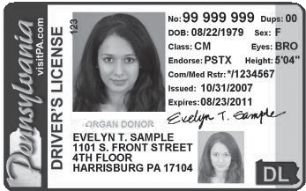
Little League® Volunteer Application – 2024
Do not use forms from past years. Use extra paper to complete if additional space is required.
This volunteer application should only be used if a league is manually entering information into JDP 7. Have you ever been refused participation in any other youth programs and/or listed on any youth organization

or an outside background check provider that meets the standards of Little League Regulations 1(c)9.
ineligible list?
 Yes
 No

THIS FORM SHOULD NOT BE COMPLETED IF A LEAGUE IS UTILIZING THE JDP QUICKAPP. Visit
LittleLeague.org/LocalBGcheck for more information.
A COPY OF VALID GOVERNMENT ISSUED PHOTO IDENTIFICATION MUST BE ATTACHED TO COMPLETE THIS APPLICATION.
All RED fields are required.
If yes, explain: (If volunteer answered yes to Question 7, the local league must contact Little League International.)
In which of the following would you like to participate? (Check one or more.)

Name

First Middle Name or Initial Last

Date
 League Official
 Coach
 Umpire
 Field Maintenance
 Manager
 Scorekeeper
 Concession Stand
 Other

Address City State Zip
Please list three references, at least one of which has knowledge of your participation as a volunteer in a youth program:
Name/Phone

Social Security # (mandatory)
Cell Phone Business Phone Home Phone: E-mail Address: Date of Birth Occupation Employer Address Special professional training, skills, hobbies:

Community affiliations (Clubs, Service Organizations, etc.):

Previous volunteer experience (including baseball/softball and year):

IF YOU LIVE IN A STATE THAT REQUIRES A SEPARATE BACKGROUND CHECK BY LAW, PLEASE ATTACH A COPY OF THAT STATE’S BACKGROUND CHECK. FOR MORE INFORMATION ON STATE LAWS, VISIT OUR WEBSITE: LittleLeague.org/BgStateLaws
AS A CONDITION OF VOLUNTEERING, I give permission for the Little League organization to conduct background check(s) on me now and as long as I continue to be active with the organization, which may include a review of sex offender registries (some of which contain name only searches which may result in a report being generated that may or may not be me), child abuse and criminal history records. I understand that, if appointed, my position is conditional upon the league receiving no inappropriate information on my background. I hereby release and agree to hold harmless from liability the local Little League, Little League Baseball, Incorporated, the officers, employees and volunteers thereof, or any other person or organization that may provide such information. I also understand that, regardless of previous appointments, Little League is not obligated to appoint me to a volunteer position. If appointed, I understand that, prior to the expiration of my term, I am subject to suspension by the President and removal by the Board of Directors for violation
of Little League policies or principles.

- Do you have children in the program?

 Yes

 No
Applicant Signature If Minor/Parent Signature
Date Date

If yes, list full name and what level?
Applicant Name (please print or type)

- Special Certification (CPR, Medical, etc.)? If yes, list:
- Do you have a valid driver’s license?

 Yes
 Yes

 No
 No
NOTE: The local Little League and Little League Baseball, Incorporated will not discriminate against any person on the basis of race, creed, color, national origin, marital status, gender, sexual orientation or disability.

Driver’s License#: State
LOCAL LEAGUE USE ONLY:
Background check completed by league officer on System(s) used for background check (minimum of one must be checked):
Review the Little League Regulation 1(c)(9) for all background check requirements
 JDP (Includes review of the US. Center of SafeSport’s Centralized Discplinary Database and Little League International Ineligible/Suspended List)*
OR
 National Criminal Database check
 National Sex Offender Registry
 U.S. Center of SafeSport’s Centralized Discplinary Database and Little League International Ineligible/Suspended List
*Please be advised that if you use JDP and there is a name match in the few states where only name match searches can be performed you should notify volunteers that they will receive a letter or email directly from JDP in compliance with the Fair Credit Reporting Act containing information regarding all the criminal records associated with the name, which may not necessarily be the league volunteer.
Only attach to this application copies of background check reports that reveal convictions of this application.
 Proof of completion of Abuse Awareness Training for Adults provided to league
- Have you ever been charged with, convicted of, plead no contest, or guilty to any crime(s) involving or against a minor, or of a sexual nature?

If yes, describe each in full:
 Yes
 No

(If volunteer answered yes to Question 4, the local league must contact Little League International.)

- Have you ever been convicted of or plead no contest or guilty to any crime(s)?
 Yes
 No

If yes, describe each in full: (Answering yes to Question 5, does not automatically disqualify you as a volunteer.)

- Do you have any criminal charges pending against you regarding any crime(s)?
 Yes
 No

If yes, describe each in full: (Answering yes to Question 6, does not automatically disqualify you as a volunteer.)

Last Updated: 10/25/23

ROSEVILLE LITTLE LEAGUE MANAGER/COACH APPLICATION

MANAGER/COACH INFORMATION (circle one)

Name: Email: Address: Phone: (H) (C)
Children in league: YES/NO List names and ages: 1:
2:
3:

MANAGING/COACHING EXPERIENCE – List most current first, include other youth organizations as well if part of your experience comes from there.
YEAR | Name of League & Division | Team | Position MGR or Coach

PLEASE LIST TWO REFERENCES WHO KNEW YOU AS A MANAGER OR COACH
Name: Phone: Name: Phone:
POSITION AND DIVISION YOU ARE INTERESTED IN: Please circle your preference below. If you wish to be considered for more than one position or division, indicate your priority by writing 1,2,3, etc.

MANAGER – COACH (circle one)
TEE BALL FARM MINOR - A AA AAA MAJOR JUNIOR SENIOR
If your selection is to manage, list the person/s you are interested to have as coach:
Tee ball AA Minor is Manager + 2 coaches
1) 2) AAA Minor & Major is Manager + 1 coach
If your selection is to coach, list the person you are interested in as a manager:
NOTE: Little Baseball Incorporated or RWLL will not discriminate against any person of race, creed, color, national origin, marital status, sex, sexual orientation or disability. Regardless of previous appointments, I may not be appointed to a Manager or Coach position. If appointed, I understand that prior to the expiration of my term I am subject to suspension by the President and removal by the Board of Directors.

REV Jan 2010

MANAGER/COACH COMMITMENT STATEMENT

NO APPLICATION WILL BE CONSIDERED UNLESS THIS COMMITMENT HAS BEEN SIGNED

If appointed as a Manager or Coach I agree to:

  - Teach players and parents fair play, good sportsmanship, and respect for all players and umpires.
  - Spend the time necessary to coach and teach my team the game of baseball at practices and games. Games are generally played twice per week. Rainouts, tie or suspended games could mean more than two (2) games per week, and could be scheduled on Saturdays, Sundays or Holidays.
  - Understand that practice, game and field scheduling may include conflicts and/or other similar issues for the team(s) I am assigned. I understand that the league, working through the respective Player Agent, will make every effort to resolve as many conflicts as possible, but cannot guarantee all issues will be accommodated.
  - Understand that if I am managing/coaching more than one team during the season, there may be event or scheduling conflicts between the teams. While the league will do everything possible to avoid such conflicts, I understand that the priority for my time is based on 1) any team I am assigned as manager, 2) any team I am assigned as coach. For any conflicts that may result in my absence, I will ensure other coaches or managers assigned to the team are available for those games or practices.
  - Attend and participate in the Mandatory eague’s Manager/ oach nstructional aseball linic (date and time ) and a Mandatory Little League First Aid and Safety Clinic (date and time TBD). Attend other Manager and Coach instructional clinics provided by the League at dates and times to be determined.
  - Attend all scheduled tryout sessions at which players eligible to participate in the Division(s) to which I am assigned to manage and/or coach participate in; and be available to participate as required, in the player draft, auction or selection process session(s) as designated by RWLL for the Division(s) to which I am assigned to manage and/or coach a team within.
  - Attend at least one (1) Manager/Coach interview sessions which should take approximately 10 to 15 minutes.
  - Practice regular communication with the league, players, families and other RWL.L members as needed/when required. In addition, provide at least one (1) e-mail address to the league that is checked at least once per day as main point of contact
  - Handle the administrative requirements of the team and participate In League functions such as parades, fieldwork days, fundraisers, etc.
  - Be responsible for safe guarding, using and returning of all equipment, facilities, and property belonging to RWLL.
  - Abide by RWLL Local League Rules and Little League Rules and Regulations.
  - Refrain from using foul language, alcohol, drugs or tobacco while around any RWLL practice or game.
  - Complete and return the Little League Volunteer Application.
  - Provide my full name, birth date and copy of my Driver’s License to the league to perform a background check on me.
In order to assist in the selection process, please respond to the following questions:
Why do you want to manage or coach?

Have you

ever been ejected from a game, or suspended from attending a game? If so, please explain?

For those who managed last season, what did you learn from the last season that will improve your skills for this season?

Why

should you be selected over other individuals interested in managing/coaching at this level?

Applicant Signature: Date:

REV Jan 2010

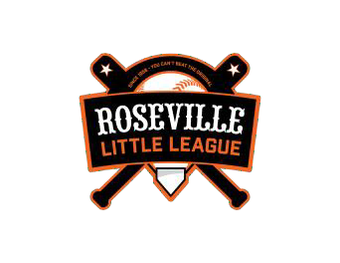
CODE OF
CONDUCT
ROSEVILLE LITTLE LEAGUE
The essential elements of character building and ethics in sports are embodied in the concept of sportsmanship and six core principles: trustworthiness, respect, responsibility, fairness, caring and good citizenship. The highest potential of sports is achieved when competition reflects these six ideals.

Therefore, as a PARENT (and/or COACH), I agree:
- I will remember that children participate to have fun and that the game is for youth, not adults.
- will inform my child’s coach of any physical disability/ailment that may affect the safety of my child/others.
- I will learn the rules of the game and the policies of the league.
- I (and my guests) will be a positive role model and encourage sportsmanship by showing respect and courtesy, and by demonstrating positive support for all players/coaches/umpires/spectators at every game, practice, or other event.
- I (and my guests) will not engage in any kind of unsportsmanlike conduct with any umpire, league official, coach, player, spectator, or parent such as: booing and taunting; refusing to shake hands; engaging in any aggressive or violent behavior; and/or using profane language or gestures.
- I will not encourage any behaviors or practices that would endanger the health and well-being of the players.
- I will teach my child to play by the rules and to resolve conflicts without resorting to hostility orviolence.
- I will demand that my child treat other players, coaches, umpires, league officials, parents, and spectators with respect regardless of race, creed, color, sex or ability.
- I will teach my child that doing one's best is more important than winning.
- I will praise my child for competing fairly and trying hard, and make my child feel like a winner every time.
- I will never ridicule or yell at my child or other participants for making a mistake or losing a game.
- I will emphasize skill development and practices and how they benefit my child over winning.
- I will promote the emotional and physical well-being of the athletes before any personal desire to win.
- I will respect the coaches and their authority during games and will never question, discuss, or confront any coach at the game field and will take time to speak with coaches at an agreed upon time and place.
- I will respect the umpires and their authority and will never aggressively challenge an umpire’s decision
either by raising my voice, gesturing or otherwise demonstrating dissent.
- I understand that no physical contact with an umpire, coach, official, spectator, or player will be tolerated.
- I will demand a sports environment for my child that is free from drugs, tobacco and alcohol and I will refrain from their use at all little league events.
- I will help ensure a litter-free environment (this includes picking up trash that may not be mine.)

If I fail to abide by any of these rules and guidelines, I may be subject to disciplinary action including, but not limited to the following:

- Verbal warning by umpire, league official, coach, and/or league board member
- Written warning
- Game suspension with written documentation of incident kept on file by RWLL
- Season Suspension
- Permanent Ban from the RWLL at the discretion of RWLL

Player Name / Parent (Guardian) Name / Parent (Guardian) Signature / Date

CODE OF
CONDUCT
ROSEVILLE LITTLE LEAGUE
The essential elements of character building and ethics in sports are embodied in the concept of sportsmanship and six core principles: trustworthiness, respect, responsibility, fairness, caring and good citizenship. The highest potential of sports is achieved when competition reflects these six ideals.

Therefore, as a PLAYER, I agree:

I hereby pledge to be positive about my youth baseball experience and accept responsibility for my participation by following this Code of Conduct.

I will encourage good sportsmanship from fellow players, coaches and parents at every game and practice by demonstrating good sportsmanship.

I will attend every practice and game that I can, and will notify my coach if I cannot. I will do my best to listen and learn from my coaches.
I will expect to receive a fair amount of playing time.

I will treat my coaches, other players, officials and fans with respect regardless of race, sex, creed, or abilities and I will expect to be treated accordingly.

I deserve to have fun during my experience and will alert my parents and coaches if it stops being fun!

I deserve to play in an environment that is free of drugs, tobacco, alcohol, and profanity and expect adults to refrain from their use at all youth sports events.

I will encourage my parents to be involved with my team in some capacity because it is important to me. I will do my very best in school.
I will remember that youth baseball is an opportunity to learn and have fun.

Player Name / Parent (Guardian) Name / Parent (Guardian) Signature / Date

COMMUNICABLE DISEASE PROCEDURES
While risk of one athlete infecting another with HIV/AIDS during competition is close to non-existent, there is a remote risk that other blood born infectious diseases can be trans- mitted. For example, Hepatitis B can be present in blood as well as in other body fluids. Procedures for reducing the potential for transmission of these infectious agents should include, but not be limited to, the following:
- The bleeding must be stopped, the open wound covered and if there is an excessive amount of blood on the uniform it must be changed before the athlete may participate.
- Routine use of gloves or other precautions to prevent skin and mucous-membrane exposure when contact with blood or other body fluids is anticipated.
- Immediately wash hands and other skin surfaces if contaminated (in contact) with blood or other body fluids. Wash hands immediately after removing gloves.
- Clean all contaminated surfaces and equipment with an appropriate disinfectant be- fore competition resumes.
- Practice proper disposal procedures to prevent injuries caused by needles, scalpels and other sharp instruments or devices.
- Although saliva has not been implicated in HIV transmission, to minimize the need for emergency mouth-to-mouth resuscitation, mouthpieces, resuscitation bags, or other ventilation devices should be available for use.
- Athletic trainers/coaches with bleeding or oozing skin conditions should refrain from all direct athletic care until the condition resolves.
- Contaminated towels should be properly disposed of/disinfected.
- Follow acceptable guidelines in the immediate control of bleeding and when handling bloody dressings, mouthguards and other articles containing body fluids.

Additional information is available from your state high school association and from the National Federation TARGET program.

COVID-19
Roseville Little League is not requiring participants and their parents/guardians to sign a COVID-19 release form for the 2024 season, however we will continue to abide by the California Department of Public Health (CDPH) guidelines for schools; a player who is not attending school due to illness is likewise not allowed to attend any Little League activities until they have recovered and are cleared to return to school. Anyone who is experiencing symptoms of illness should stay home until their symptoms have resolved. For more guidance, Roseville Little League encourages parents/volunteers to contact their own, or their children’s, physician.

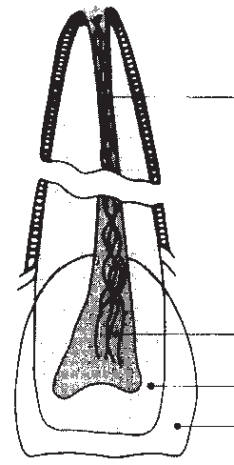Dental Injuries
Emergency Treatment of Athletic Dental Injuries

Pulp Canal (root canal)

Root

Pulp (nerves, blood vessels)
Crown
Dentin

Enamel

Professionally-made, properly fitted Custom Mouthguards greatly reduce the risk and severity of mouth injuries. Mouthguards are recommended injury prevention equipment for all at-risk sports.

AVULSION (Entire Tooth Knocked Out)

- Avoid additional trauma to tooth while handling. Do Not handle tooth by the root. Do Not brush or scrub tooth. Do Not sterilize tooth.
- If debris is on tooth, gently rinse with water.
- If possible, reimplant and stabilize by biting down gently on a towel or handkerchief. Do only if athlete is alert and conscious.
- If unable to reimplant:
Best - Place tooth in Hank’s Balanced Saline Solution, i.e. “Save-a-tooth.”
2nd best - Place tooth in milk. Cold whole milk is best, followed by cold 2% milk.
3rd best - Wrap tooth in saline-soaked gauze. 4th best - Place tooth under athlete’s tongue. Do this ONLY if athlete is conscious and alert.
5th best - Place tooth in cup of water.
- Time is very important. Reimplantation within 30 minutes has the highest degree of success rate. TRANSPORT IMMEDIATELY TO DENTIST.
LUXATION (Tooth in Socket, But Wrong Position)
THREE POSITIONS
EXTRUDED TOOTH - Upper tooth hangs down and/or lower tooth raised up.
- Reposition tooth in socket using firm finger pressure.
- Stabilize tooth by gently biting on towel or hand- kerchief.
- TRANSPORT IMMEDIATELY TO DENTIST.
LATERAL DISPLACEMENT - Tooth pushed back or pulled forward.
- Try to reposition tooth using finger pressure.
- Athlete may require local anesthetic to reposi- tion tooth; if so, stabilize tooth by gently biting on towel or handkerchief.
- TRANSPORT IMMEDIATELY TO DENTIST.
INTRUDED TOOTH - Tooth pushed into gum - looks short.
- Do nothing - avoid any repositioning of tooth.
- TRANSPORT IMMEDIATELY TO DENTIST.
FRACTURE (Broken Tooth)
- If tooth is totally broken in half, save the broken portion and bring to the dental office as described under Avulsion, Item 4. Stabilize portion of tooth left in mouth by gently biting on towel or handker- chief to control bleeding.
- Should extreme pain occur, limit contact with other teeth, air or tongue. Pulp nerve may be exposed, which is extremely painful to athlete.
- Save all fragments of fractured tooth as described under Avulsion, Item 4.
- IMMEDIATELY TRANSPORT PATIENT AND TOOTH FRAGMENTS TO DENTIST.

Academy for Sports Dentistry
875 North Michigan Ave.
Suite 4040
Chicago, IL 60611-1901

1800-273-1788
1800-ASD-1788
MOUTHGUARDS SHOULD NOT BE OPTIONAL EQUIPMENT
The Academy for Sports Dentistry, a professional organization dedicated to the dental needs of ath- letes at risk to sports injuries, recommends that every sports medicine team include a dentist knowledgeable in sports dentistry.

23

Concussion
INFORMATION SHEET

This sheet has information to help protect your children or teens from concussion or other serious brain injury. Use this information at your children’s or teens’ games and practices to learn how to spot a concussion and what to do if a concussion occurs.

What Is a Concussion?
A concussion is a type of traumatic brain injury—or TBI— caused by a bump, blow, or jolt to the head or by a hit to the body that causes the head and brain to move quickly back and forth. This fast movement can cause the brain to bounce around or twist in the skull, creating chemical changes in the brain and sometimes stretching and damaging the brain cells.

How Can I Help Keep
My Children or Teens Safe?
Sports are a great way for children and teens to stay healthy and can help them do well in school. To help lower your children’s or teens’ chances of getting a concussion or other serious brain injury, you should:
- Help create a culture of safety for the team.
  - Work with their coach to teach ways to lower the chances of getting a concussion.
  - Talk with your children or teens about concussion and ask if they have concerns about reporting a concussion. Talk with them about their concerns; emphasize the importance of reporting concussions and taking time to recover from one.
  - Ensure that they follow their coach’s rules for safety and the rules of the sport.
  - Tell your children or teens that you expect them to practice good sportsmanship at all times.
- When appropriate for the sport or activity, teach your children or teens that they must wear a helmet to lower the chances of the most serious types of brain or head injury. However, there is no “concussion-proof” helmet. So, even with a helmet, it is important for children and teens to avoid hits to the head.

How Can I Spot a Possible Concussion?

Plan ahead. What do you want your child or teen to know about concussion?
Children and teens who show or report one or more of the signs and symptoms listed below—or simply say they just “don’t feel right” after a bump, blow, or jolt to the head or body—may have a concussion or other serious brain injury.
Signs Observed by Parents or Coaches
- Appears dazed or stunned
- Forgets an instruction, is confused about an assignment or position, or is unsure of the game, score, or opponent
- Moves clumsily
- Answers questions slowly
- Loses consciousness (even briefly)
- Shows mood, behavior, or personality changes
- Can’t recall events prior to or after a hit or fall
Symptoms Reported by Children and Teens
- Headache or “pressure” in head
- Nausea or vomiting
- Balance problems or dizziness, or double or blurry vision
- Bothered by light or noise
- Feeling sluggish, hazy, foggy, or groggy
- Confusion, or concentration or memory problems
- Just not “feeling right,” or “feeling down”

cdc.gov/HEADSUP
children and teens think concussions aren’t serious, or worry that if they report
a concussion they will lose their position on the team or look weak. Be sure to remind them that it’s better to miss one game than the whole season.

Talk with your children and teens about concussion. Tell them to report their concussion symptoms to you and their coach right away. Some

CONCUSSIONS AFFECT EACH CHILD AND TEEN DIFFERENTLY.

While most children and teens with a concussion feel better within a couple of weeks, some will have symptoms for months or longer. Talk with your children’s or teens’ healthcare provider if their concussion symptoms do not go away, or if they get worse after they return to their regular activities.

What Are Some More Serious Danger Signs to Look Out For?
In rare cases, a dangerous collection of blood (hematoma) may form on the brain after a bump, blow, or jolt to the head or body and can squeeze the brain against the skull. Call 9-1-1 or take your child or teen to the emergency department right away if, after a bump, blow, or jolt to the head or body, he or she has one or more of these danger signs:
- One pupil larger than the other
- Drowsiness or inability to wake up
- A headache that gets worse and does not go away
- Slurred speech, weakness, numbness, or decreased coordination
- Repeated vomiting or nausea, convulsions or seizures (shaking or twitching)
- Unusual behavior, increased confusion, restlessness, or agitation
- Loss of consciousness (passed out/knocked out). Even a brief loss of consciousness should be taken seriously
Children and teens who continue to play while having concussion symptoms, or who return to play too soon—while the brain is still healing—have a greater chance of getting another
concussion. A repeat concussion that occurs while the brain is still healing from the first injury can be very serious, and can affect a child or teen for a lifetime. It can even be fatal.

What Should I Do If My Child or Teen Has a Possible Concussion?
As a parent, if you think your child or teen may have a concussion, you should:
- Remove your child or teen from play.
- Keep your child or teen out of play the day of the injury. Your child or teen should be seen by a healthcare provider and only return to play with permission from a healthcare provider who is experienced in evaluating for concussion.
- Ask your child’s or teen’s healthcare provider for written instructions on helping your child or teen return to school. You can give the instructions to your child’s or teen’s school nurse and teacher(s) and return-to-play instructions to the coach and/or athletic trainer.
Do not try to judge the severity of the injury yourself. Only a healthcare provider should assess a child or teen for a possible concussion. Concussion signs and symptoms often show up soon after the injury. But you may not know how serious the concussion is at first, and some symptoms may not show up for hours or days.
The brain needs time to heal after a concussion. A child’s or teen’s return to school and sports should be a gradual process that is carefully managed and monitored by a healthcare provider.

To learn more, go to cdc.gov/HEADSUP

- I learned about concussion and talked with my parent or coach about what to do if I have a concussion or other serious brain injury. Athlete’s Name Printed: Date: Athlete’s Signature:
- I have read this fact sheet for parents on concussion with my child or teen, and talked about what to do if they have a concussion or other serious brain injury.
Parent or Legal Guardian’s Name Printed: Date: Parent or Legal Guardian’s Signature:
Revised January 2019

Discuss the risks of concussion and other serious brain injuries with your child or teen, and have each person sign below. Detach the section below, and keep this information sheet to use at your children’s or teens’ games and practices to help protect them from concussion or other serious brain injuries.

HEADS UP to Youth Sports: Online Training
https://www.cdc.gov/concussion/HeadsUp/Training/index.html

Changing the Culture of Concussion Starts With You!

By taking this free, online course and using what you learn, you will be well positioned to improve the culture of concussion. Your actions can help create a safe environment for young athletes so that they can stay healthy, active, and thrive - both on and off the playing field.
Once you complete the training and quiz, you can print out a certificate, making it easy to show your league or school you are ready for the season.
What Will I Learn in This Training?
This course will help you:

  - Understand a concussion and the potential consequences of this injury,
  - Recognize concussion signs and symptoms and how to respond,
  - Learn about steps for returning to activity (play and school) after a concussion, and
  - Focus on prevention and preparedness to help keep athletes safe season-to-season.

We can help athletes stay active and healthy by knowing the facts about concussion and when it is safe for athletes to return to play.
CDC HEADS UP Concussion Training Saves Lives
D ’s coaches concussion training helped a coach to recogni e and respond to concussion in a
young athlete.

What Are the Technical Requirements for This Training?

This training works best on an up-to-date computer (for example, one with a multi core processor) with a broadband internet connection, as well as an up-to-date web browser and operating system. Older computers may crash while using the training resulting in a loss of your progress through the training. Please do not close or refresh your browser as this will restart the training. We do not collect any personal in ormation or track or record any individual’s use o this training, so if you need to exit the training, you will be returned to the start of the training.
At the end of the training, you will be able to print one or more copies and/or save an electronic version of your certificate of completion to your desktop. In order to print your certificate of completion, please use the print button found within the training. You will not be able to print the certificate using your tool bar or keyboard. While this training does run on smart phones and tablets, a printer connection or a PDF writer is needed to print your certificate of completion.
Please feel free to contact DUIPinquiries@cdc.gov if you are having trouble accessing the course.

Can I Get a Replacement Copy of My Certificate?
Unfortunately, we are unable to provide replacement copies of certificates, as we do not collect any
personal in ormation or track or record any individual’s use o this training.

How Often Do I Need to Take This Training?
How often the HEADS UP online training needs to be taken varies by individual states, leagues, and schools. We recommend that you check with your state, league, or school regarding their specific requirements on how often you need to complete this training.
How Can I Host a Group Training?
If you would like to host a group training using this course, you are able to order a copy of the course on CD-Rom. Please note that the CD-Rom does not include a certificate of completion. Instead, we can provide you with a group training certificate. The group training certificate does require a signature from the training facilitator or person hosting the training. If you would like to obtain a copy of the CD-Rom and the group training certificate, please contact DUIPinquiries@cdc.gov.

Fact Sheet for Parents & Student Athletes
This sheet has information to help protect your student athlete from Sudden Cardiac Arrest
Why do heart conditions that put student athletes at risk go undetected?
While a student athlete may display no warning signs of a heart condition, studies do show that symptoms are typically present but go unrecognized, unreported, missed or misdiagnosed.

- Symptoms can be misinterpreted as typical in active student athletes
- Fainting is often mistakenly attributed to stress, heat, or lack of food or water
- Student athletes experiencing symptoms regularly don’t recognize them as unusual
– it’s their normal
- Symptoms are not shared with an adult because student athletes are embarrassed they can’t keep up
What happens if my student has warning signs or risk factors?
- State law requires student athletes who faint or exhibit other cardio-related symptoms to be re-cleared to play by a licensed medical practitioner.
- Ask your health care provider for diagnostic or genetic testing to rule out a possible heart condition.
Electrocardiograms (ECG or EKG) record the electrical activity of the heart. ECGs have been shown to detect a majority of heart conditions more effectively than physical and health history alone. Echocardiograms (ECHO) capture a live picture of the heart.
- Your student should be seen by a health care provider who is experienced in evaluating cardiovascular (heart) conditions.
- Follow your providers instructions for recommended activity limitations until testing is complete.
Protect Your Student’s Heart
Educate yourself about sudden cardiac arrest, talk with your student about warning signs, and create a culture of prevention in your school sports program.
- Know the warning signs
- Document your family’s heart health history as some conditions can be inherited
- If symptoms/risk factors present, ask your doctor for follow-up heart/genetic testing
- Don’t just “check the box” on health history forms—ask your student how they feel
- Take a cardiac risk assessment with your student each season
- Encourage student to speak up if any of the symptoms are present
- Check in with your coach to see if they’ve noticed any warning signs
- Active students should be shaping up, not breaking down
- As a parent on the sidelines, know the cardiac chain of survival
- Be sure your school and sports organizations comply with state law to have administrators, coaches and officials trained to respond to a cardiac emergency
- Help fund an onsite AED
- Student athletes mistakenly think they’re out of shape and just need to train harder
- Students (or their parents) don’t want to jeopardize playing time
- Students ignore symptoms thinking they’ll just go away
- Adults assume students are OK and just “check the box” on health forms without asking them
- Medical practitioners and parents alike often miss warning signs
- Families don’t know or don’t report heart health history or warning signs to their medical practitioner
- Well-child exams and sports physicals do not check for conditions that can put student athletes at risk
- Stethoscopes are not a comprehensive diagnostic test for heart conditions

What if my student is diagnosed with a heart condition that puts them at risk?
There are many precautionary steps that can be taken to prevent the onset of SCA including activity modifications, medication, surgical treatments, or implanting a pacemaker and/or implantable cardioverter defibrillator (ICD). Your practitioner should discuss the treatment options with you and any recommended activity modifications while undergoing treatment. In many cases, the abnormality can be corrected and students can return to normal activity.

What is Sudden Cardiac Arrest? Sudden Cardiac Arrest (SCA) is a life-threatening emergency that occurs when the heart
suddenly stops beating. It strikes people of all ages who may seem to be healthy, even children and teens. When SCA happens, the person collapses and doesn’t respond or breathe normally. They may gasp or shake as if having a seizure, but their heart has stopped. SCA leads to death in minutes if the person does not get help right away. Survival depends on people nearby calling 911, starting CPR, and using an automated external defibrillator (AED) as soon as possible.

FAINTING
IS THE #1 SYMPTOM
OF A HEART CONDITION

What CAUSES SCA?
SCA occurs because of a malfunction in the heart’s electrical system or structure. The malfunction is caused by an abnormality the person is born with, and may have inherited, or a condition that develops as young hearts grow. A virus in the heart or a hard blow to the chest can also cause a malfunction that can lead to SCA.
How COMMON is SCA?
As a leading cause of death in the U.S., most people are surprised to learn that SCA is also the #1 killer of student athletes and the leading cause of death on school campuses. Studies show that 1
in 300 youth has an undetected heart condition that puts them at risk.
Factors That Increase the Risk of SCA
V Family history of known heart abnormalities or sudden death before age 50
V Specific family history of Long QT Syndrome, Brugada Syndrome, Hypertrophic Cardiomyopathy, or Arrhythmogenic Right Ventricular Dysplasia (ARVD)
V Family members with known unexplained fainting, seizures, drowning or near drowning or car accidents
V Family members with known structural heart abnormality, repaired or unrepaired
V Use of drugs, such as cocaine, inhalants, “recreational” drugs, excessive energy drinks, diet pills or performance-enhancing supplements

Cardiac Chain of Survival
RECOGNIZE THE WARNING SIGNS & RISK FACTORS
Ask Your Coach and Consult Your Doctor if These Conditions are Present in Your Student

Potential Indicators That SCA May Occur
- Fainting or seizure, especially during or right after exercise
- Fainting repeatedly or with excitement or startle
- Excessive shortness of breath during exercise
- Racing or fluttering heart palpitations or irregular heartbeat
- Repeated dizziness or lightheadedness
- Chest pain or discomfort with exercise
- Excessive, unexpected fatigue during or after exercise
Their life depends on your quick action! CPR can triple the chance of survival.
Start immediately and use the onsite AED.
KeepTheirHeartInTheGame.org

Fact Sheet for Parents & Student Athletes

This sheet has information to help protect your student athlete from Sudden Cardiac Arrest

To learn more, go to KeepTheirHeartInTheGame.org
Get free tools to help create a culture of prevention at home, in school, on the field and at the doctor’s office.
Discuss the warning signs of a possible heart condition with your student athlete and have each person sign below.

Detach this section below and return to your school.
Keep the fact sheet to use at your students’ games and practices to help protect them from Sudden Cardiac Arrest.

I learned about warning signs and talked with my parent or coach about what to do if I have any symptoms.

STUDENT ATHLETE NAME PRINTED STUDENT ATHLETE SIGNATURE DATE

I have read this fact sheet on sudden cardiac arrest prevention with my student athlete and talked about what to do if they experience any warning signs, and what to do should we witness a cardiac arrest.

PARENT OR LEGAL GUARDIAN PRINTED PARENT OR LEGAL GUARDIAN SIGNATURE DATE

While missing a game may be inconvenient, it would be a tragedy to lose a student athlete because warning signs were unrecognized or because sports communities were not prepared to respond to a cardiac emergency.
Keep Their Heart In the Game!

Hey Coach, Have You:

3Walked field for debris/foreign objects 3Inspected helmets, bats, catchers’ gear 3Made sure a First Aid kit is available
3Check conditions of fences, backstops, bases and warning track
3Made sure a cell phone is available in case of an emergency
3Held a warm-up drill

Requirement 8 of 13 To Meet Safety Plan Minimum Requirements
Using Facility Surveys

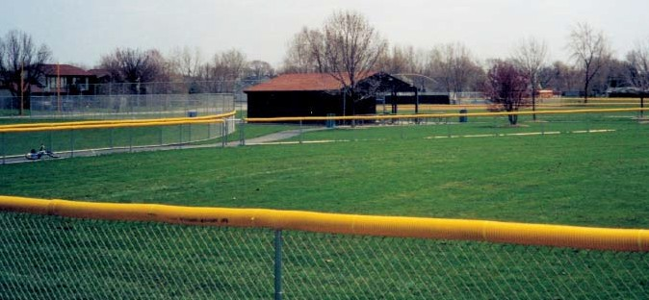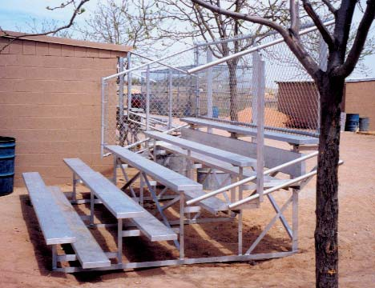What exactly is the National Facility Survey, and how does it help? Many people think filling it out one time will “cover their bases” for years to come.
The truth is, you won’t know what has changed at your facility if you don’t look. Use the survey to look for concerns and ways to improve, even if facilities haven’t deteriorated. If an area has gotten worse, this
is the perfect reminder to work on it now. The worst situation your league can face is fixing a hole in a field or a broken seat in your bleachers only after a child
allows the batter to see the ball right
out of the pitcher’s hand and react faster to avoid injuries from wild pitches.
Have you considered breakaway or quick-release bases? Studies continue to show leg, ankle and foot injuries – the majority of base runners’ injuries – can largely be avoided with these safety devices.

- Do you test light levels annually before each season?
- Do you have an electrician check lights’ electrical system for safety annually?
- Do you clearly separate parking areas from spectator areas?
- Do you have telephone access

or parent is injured.
Some questions suggest changes to avoid injuries that have not and need
Safety takes effort: (above) Adding protective tubing to fence tops reduces risk of players being injured reaching for home-run balls; (top right) bleachers are more safe with handrails and back guards; (below) ball returns help get balls into play safely; (bottom) and safety bases reduce sliding injuries.
at all fields?
- Do you provide first aid kits to all teams?
These are all part of the Facility

not happen. Here are a few to consider:
If your concession stand is by homeplate and no one has been hit by a foul
ball, count yourself lucky and consider overhead netting. People standing
with their backs to the field don’t respond quickly. The same is true for fields that share a common foul line and spectator area.
Dark screening at backstop and center field is a major league upgrade at minor league prices. An inexpensive pitcher’s eye, the wood or fabric dark screening behind the catcher on the backstop, helps pitchers more quickly pick up a ball off the bat, and react. The batter’s eye, behind the pitcher in center field,
Quick Hitters:
- Do you use double first bases?
- Do you ground metal bleachers?
- 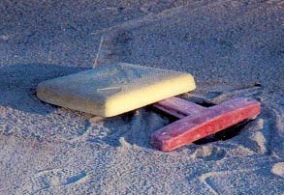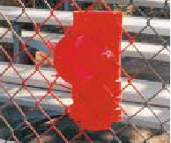Do you inspect wooden bleachers annually?
- Do bleachers have hand and back guard rails if required (see local codes)?
- Do you install warning tracks for all fields?
- Do you have fenced, limited access bull pens?
- Do you provide fence caps to protect fielders from injury on wire fence edges?
Survey. Taking a fresh look each year at your fields can help your league avoid accidents and injuries that you didn’t even know could
happen. If you adopt these changes, you need never know.

LITTLE LEAGUE BASEBALL® & SOFTBALL
NATIONAL FACILITY SURVEY
2020
League Name: Roseville | Little | League
District #: 54
ID #: 405-54-09 |  |  | _
ID #:
ID #:
City: Roseville | State: CA |  | _

(if needed)
(if needed)

President: Pete Godtfredsen |  | Safety Officer: Kellie Allen _
Address: |  | Address:
Address: |  | Address:
City: Roseville |  | City: Roseville _
State: CA ZIP: |  | State: CA ZIP:
Phone (work): |  | Phone (work):
Phone (home): |  | Phone (home):
Phone (cell): (916) 276-5150 |  | Phone (cell): (916)206-2852
Email: president@rwll.net |  | Email: safety@rwll.net

PLANNING TOOL FOR FUTURE LEAGUE NEEDS
What are league's plans for improvements? | Indicate number of fields in boxes below.
 | Next 12 mons. | 1-2 yrs. | 2+ yrs.
a. New fields
b. Basepath/infield
c. Bases
d. Scoreboards
e. Pressbox
f. Concession stand
g. Restrooms
h. Field lighting
i. Warning track
j. Bleachers
k. Fencing
l. Bull pens
m. Dugouts
n. Other (specify):

SPECIFIC BALLFIELD QUESTIONS
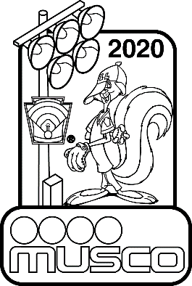
- Please list all fields by name.

Field Identification (List your ballfields 1-20) Use additional forms if more than 20 fields. |  | 1 | 2 | 3 | 4 | 5 | 6 | 7 | 8 | 9 | 10 11 |  | 12 | 13 | 14 | 15 | 16 | 17 | 18 | 19 | 20
ASAP - A Safety Awareness Program  Limited Edition 10-year Pin Collection  This survey can assist in finding areas of focus for your safety plan. During your annual field inspections, please complete this form and return along with your qualified safety plan. In return, we'll send you the 2020 Disney® character collector's pin shown at right featuring Windup the pitcher. |  | Name: | Name: | Name: | Name: | Name: | Name: | Name: | Name: | Name: | Name: | Name: | Name: | Name: | Name: | Name: | Name: | Name: | Name: | Name: | Name:
Please answer the following questions for each field: | Field # | 1 | 2 | 3 | 4 | 5 | 6 | 7 | 8 | 9 | 10 | 11 | 12 | 13 | 14 | 15 | 16 | 17 | 18 | 19 | 20
GENERAL INVENTORY | (For the following questions, if the answer is "No" please leave the space blank.)
1. How many cars can park in designated parking areas? | None
 | 1-50
 | 51-100
 | 101 or more
2. How many people can your bleachers seat? | None/NA
 | 1-100
 | 101-300
 | 301-500
 | 501 or more
3. What material is used for bleachers? | Wood
 | Metal
 | Other
4. Metal bleachers: Ground wire attached to ground rod? | Yes
5. Wood bleachers: Are inspected annually for safety? | Yes
6. Is a safety railing at the top/back of bleachers? | Yes
7. Is a handrail up the sides of bleachers? | Yes
8. Is telephone service available? | Permanent
 | Cellular
9. Is a public address system available? | Permanent
 | Portable
10. Is there a pressbox? | Yes
11. Is there a scoreboard? | Yes
12. Adequate bathroom facilities available? | Yes
13. Permanent concession stands? | Yes
14. Mobile concession stands? | Yes

 | Field # | 1 | 2 | 3 | 4 | 5 | 6 | 7 | 8 | 9 | 10 | 11 | 12 | 13 | 14 | 15 | 16 | 17 | 18 | 19 | 20
FIELD
15. Is field completely fenced? | Yes
16. What type of fencing material is used? | Chainlink
 | Wood
 | Wire
17. What base path material is used? | Sand, clay, soil mix
 | Ground burnt brick
 | Other:
18. What is used to mark baseline? | Non-caustic lime
 | Spray paint
 | Commerc'l marking
19. Is your the infield surface grass? | Yes
20. Does field have conventional dirt pitching mound? | Yes
21. Does field have a temporary pitching mound? | Yes
22. Are there foul poles? | Yes
23. Backstop behind home plate? | Yes
PERFORMANCE AND PLAYER SAFETY
24. Is there an outfield warning track? | Yes
24.a. If yes, what width is warning track? Please specify: | (Width in feet)
25. Batter's eye (screen/covering) at center field? | Yes
26. Pitcher's eye (screen/covering) behind home plate? | Yes
27. Are there protective fences in front of the dugouts? | Yes
28. Is there a protected, on-deck batter's area? (On-deck areas have  been eliminated for ages 12 and below.) | Yes
29. Do you have fenced, limited access bull pens? | Yes
30. Is a first aid kit provided per field? | Yes
31. Do bleachers have spectator foul ball protection? | Overhead screens
 | Fencing behind
32. Do your bases disengage from their anchors? (Mandatory since 2008) | Yes
33. Is the field lighted? | Yes
34. Are light levels at/above Little League standards? | Yes
(50 footcandles infield/30 footcandles outfield) | Don't know
35. What type of poles are used? | Wood*
(Wood poles have not been allowed by Little League | Steel
for new construction of lighting since 1994) | Concrete
36. Is electrical wiring to each pole underground? | Yes
37. Ground wires connected to ground rods on each pole? | Yes
38. Which fields were tested/inspected in the last two years? | Electrical System
Please indicate month/year testing was done (example: 3/10) | Light Levels
39. Fields tested/inspected by qualified technician? | Electrical System
 | Light Levels

 | Field # | 1 | 2 | 3 | 4 | 5 | 6 | 7 | 8 | 9 | 10 | 11 | 12 | 13 | 14 | 15 | 16 | 17 | 18 | 19 | 20
FACILITY MANAGEMENT
40. Which fields have the following limitations:
a. Amount of time for practice? | Yes
b. Number of teams or games? | Yes
c. Scheduling and/or timing? | Yes
41. Who owns the field? | Municipal
 | School
 | League
42. Who is responsible for operational energy costs? | Municipal
 | School
 | League
43. Who is responsible for operational maintenance? | Municipal
 | School
 | League
44. Who is responsible for puchasing improvements | Municipal
for the field - ie bleachers, fences, lights? | School
 | League
 | Other
45. What divisions of baseball play on each field? | T-Ball & Minor
 | Major
 | Jr., Sr. & Big
 | Challenger
 | 50 – 70
46. What divisions of softball play on each field? | T-Ball & Minor
 | Major
 | Jr., Sr. & Big
 | Challenger
47. Do you plan to host tournaments on this field? | Yes

FIELD DIMENSION DATA
Please complete for each field. Use additional space if necessary.

 | Height | Distance from home plate to: |  |  |  | Foul territory distance from:
 | of | Outfield fence |  |  |  | Left field line to fence at: |  |  | Right field line to fence at:
Field | outfield | Left | Center | Right | Back | Home | 3rd | Outfield | Home | 1st | Outfield
No. | fence |  |  |  | stop |  |  | foul pole |  |  | foul pole
1
2
3
4
5
6
7
8
9
10
11
12
13
14
15
16
17
18
19
20

Mailing address:
Little League International
PO Box 3485
Williamsport, PA 17701

Shipping address:
Little League International
539 US Route 15 Hwy.
South Williamsport, PA 17702

Concession Stand Tips
Requirement 9 SAFETY FIRST

12 Steps to Safe and Sanitary Food Service Events: The following information is intended to help you run a healthful concession stand.
Following these simple guidelines will help minimize the risk of foodborne illness. This information was provided by District Administrator George Glick, and is excerpted from "Food Safety Hints" by the Fort Wayne-Allen County, Ind., Department of Health.
- Menu.
Keep your menu simple, and keep potentially hazardous foods (meats, eggs, dairy products, protein salads, cut fruits and vegetables, etc.) to a minimum.
Avoid using precooked foods or leftovers. Use only foods from approved sources, avoiding foods that have been prepared at home. Complete control over your food, from source to service, is the key to safe, sanitary food service.
- Cooking.
Use a food thermometer to check on cooking and holding temperatures of potentially hazardous foods. All potentially hazardous foods should be kept at 41º F or below (if cold) or 140º F or above (if hot). Ground beef and ground pork products should be cooked to an internal temperature of
155º F, poultry parts should be cooked to 165º F. Most foodborne illnesses from temporary events can be traced back to lapses in temperature control.

4 January-February 2004
- Reheating.
Rapidly reheat potentially hazardous foods to 165º F. Do not attempt to heat foods in crock pots, steam tables, over sterno units or other holding devices.
Slow-cooking mechanisms may activate bacteria and never reach killing temperatures.
- Cooling and Cold Storage.
Foods that require refrigeration must
be cooled to 41º F as quickly as possible and held at that temperature until ready to serve. To cool foods down quickly, use an ice water bath (60% ice to 40% water), stirring the product frequently, or place the food in shallow pans no more than 4 inches in depth and refrigerate. Pans should not be stored one atop the other and lids should be
off or ajar until the food is completely cooled. Check temperature periodically to see if the food is cooling properly. Allowing hazardous foods to remain unrefrigerated for too long has been the number ONE cause of foodborne illness.
- Hand Washing.
Frequent and thorough hand washing remains the first line of defense in preventing foodborne disease. The
use of disposable gloves can provide an additional barrier to contamination, but they are no substitute for hand washing!
- Health and Hygiene.
Only healthy workers should prepare and serve food. Anyone who shows symptoms of disease (cramps, nausea, fever, vomiting, diarrhea, jaundice, etc.) or who has open sores or infected cuts on the hands should not be allowed
in the food concession area. Workers should wear clean outer garments and should not smoke in the concession area. The use of hair restraints is recommended to prevent hair ending up in food products.
- Food Handling.
Avoid hand contact with raw, ready- to-eat foods and food contact surfaces. Use an acceptable dispensing utensil
to serve food. Touching food with bare hands can transfer germs to food.
- Dishwashing.
Use disposable utensils for food service. Keep your hands away from food contact surfaces, and never reuse disposable dishware. Wash in a four-step process:
  - Washing in hot soapy water;
  - Rinsing in clean water;
  - Chemical or heat sanitizing; and
  - Air drying.
- Ice.
Ice used to cool cans/bottles should
not be used in cup beverages and should be stored separately. Use a scoop to dispense ice; never use the hands. Ice can become contaminated with bacteria and viruses and cause foodborne illness.
- Wiping Cloths.
Rinse and store your wiping cloths in
a bucket of sanitizer (example: 1 gallon of water and 1⁄2 teaspoon of chlorine bleach). Change the solution every
two hours. Well sanitized work surfaces prevent cross-contamination and discourage flies.
- Insect Control and Waste.
Keep foods covered to protect them from insects. Store pesticides away from foods. Place garbage and paper wastes in a refuse container with a tight- fitting lid. Dispose of wastewater in an approved method (do not dump it outside). All water used should be potable water from an approved source.
- Food Storage and Cleanliness. Keep foods stored off the floor at least six inches. After your event is finished, clean the concession area and discard unusable food.
- Set a Minimum Worker Age. Leagues should set a minimum age for workers or to be in the stand; in many states this is 16 or 18, due to potential hazards with various equipment.
Safety plans must be postmarked no later than May 1st.

Volunteers Must Wash Hands
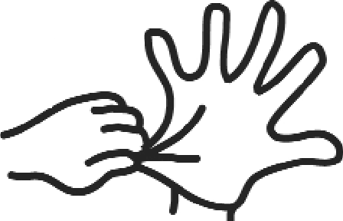--.v,111,'• - - - - - - - - - - - - - - - -

Wet
warm water

Wash
20 seconds Use soap

Rinse

Dry
Use single-service paper towels

Gloves
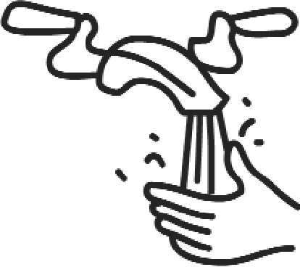
Wash your hands before you
prepare food or as often as needed.

Wash after you:
- use the toilet
- touch uncooked meat, poultry , fish or eggs or other
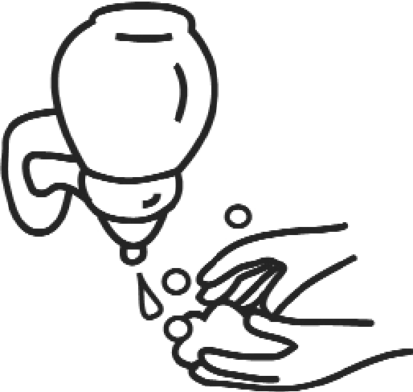
potentially hazardous foods
- interrupt working with food (such as answering the
phone, opening a door or drawer)
►
eat, smoke or chew gum
- touch soiled plates, utensils or equipm ent
- take out trash
- touch your nose, mouth, or any part of your body
- sneeze or cough

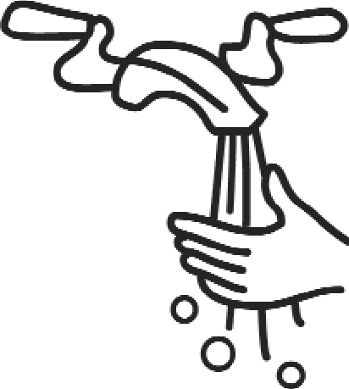
Do not touch ready-to-eat foods with your bare hands.
Use gloves, tongs, deli tissue or other serving utensils.
Remove all j ewelry, nail polish or false nails unless you wear gloves.

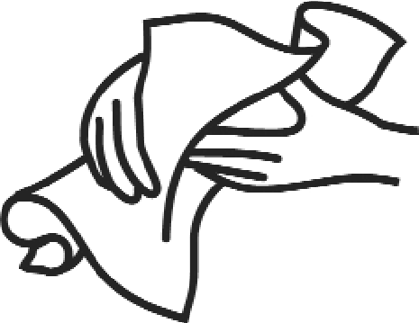
Wear gloves.
when you have a cut or sore on your hand when you ca n't remove your jewelry

If you wear gloves:
- wash your hands before you put on new gloves
Change them:
- as often as you wash your hands
- when they are torn or soiled

Developed by UMass Extension Nu trition Educ ation Program with support from U.S. Food & Drug Administration in cooperation with the MA Partnership for Food Safety Edu cation. United States Department of Agriculture Cooperating. UMass Extension pro­ vides equal opportunity in programs and employment.

UM ASS
IKIINSION

Regular Inspection and Replacement of Equipment:

All equipment bags are returned to the league each fall.
All equipment is inspected and replaced or repaired before bags are redistributed.
Coaches and managers are required to inspect equipment throughout the year and repair or replace as necessary.
Damaged equipment is returned to the league so that it is not used inappropriately.
Only bats marked with the USA Baseball stamp are permitted.
Managers, umpires and coaches are to inspect equipment prior to each game.

Equipment Checklist
Keep Your Players Safer

Do you know what equipment is required for player safety on the field? Do you know which optional items can help keep players safer? Check out the following list for ideas and reminders.

REQUIRED PLAYER EQUIPMENT
Defense
- Athletic supporter – all male players
- Metal, fiber, or plastic type cup – all male catchers
- Catcher’s helmet and mask, with “dangling” throat guard; NO skull caps – all catchers; must be worn during pitcher warm-up, infield practice, while batter is in box
- Catcher’s mitt – all baseball catchers
- Chest protector and leg protectors – all catchers; must be worn while batter is in box; long model chest protector required for Little League (Majors) and younger catchers
Offense
- Helmet meeting NOCSAE standards – all batters, base runners, and players in coaches boxes
- Helmet chinstrap – all helmets made to have chinstrap (with snap buttons, etc.)
- Regulation-sized ball for the game and division being played; marked RS for regular season or RS-T for regular season and tournament in baseball
- Regulation-sized bat – all batters; Little League (Majors) and younger baseball divisions must have bat marked with BPF 1.15 beginning in 2009
- Non-wood bats must have a grip of cork, tape, or composite material, and must extend a minimum of
10 inches from the small end. Slippery tape is prohibited.

REQUIRED FIELD EQUIPMENT
- 1st, 2nd and 3rd bases that disengage from their anchors
- Pitcher’s plate and home plate
- Players’ benches behind protective fences
- Protective backstop and sideline fences

OPTIONAL PLAYER EQUIPMENT
Defense
- Metal, fiber, or plastic type cup – any player, esp. infielders
- Pelvic protector – any female, esp. catchers
- Heart Guard/XO Heart Shield/Female Rib Guard – any defensive player, esp. pitchers, infielders
- Game-Face Safety Mask – any player, esp. infielders
- Goggles/shatterproof glasses – any player, esp. infielders or those with vision limitations
Offense
  - Helmet – adults in coaches boxes
  - Helmet with Face Guards or C-Flap meeting NOCSAE standards – all batters, esp. in younger divisions
  - Mouth guard – batters, defensive players
  - Goggles/Shatterproof glasses – any player, esp. those with vision limitations
  - Batters vest/Heart Guard/Heart Shield/Female Rib Guard – any batter
  - Regulation-sized reduced impact ball
OPTIONAL FIELD EQUIPMENT
  - Double 1st base that disengages from its anchor
  - Baseball mound for pitcher’s plate
  - Portable pitchers baseball mound with pitcher’s plate
  - Protective/padded cover for fence tops
  - Foul ball return in backstop fencing

BPF RULE GOES INTO EFFECT FOR BASEBALL DIVISIONS
IMPORTANT:
Buying bats for your league’s baseball divisions? If it is composite metal, make sure it has the BPF 1.15 label. Bats in use in Little League Baseball (Majors Division and younger) must have the new bat performance factor listed on the bat.
Unless this marking is present, the bat will be removed from games.
Little League officials are aware some bats do not have the required markings but are Little League approved. And some of the bats on the approved bat list may not carry the required BPF 1.15 marking, depending on when they were manufactured and licensed.
Little League is building a list of bats that are approved but do not have the BPF marking due to special circumstances. For these bats, the eligibility for play will be extended until December 31, 2009. As Little League is made aware of bats that meet the BPF rule for this extension, the bats will be added to the list.
ONLY bats with a BPF 1.15 marking or that are listed below will be allowed for use in the Little League (Majors) Baseball and younger divisions in 2009.
Non-BPF-marked bats approved until Dec. 31, 2009:
Adidas – Vanquish (blue design) A newer model of this bat, also named Vanquish with copper and black markings, has the proper labeling, so is therefore not subject to the one-year rule.
DeMarini – Black Coyote, Rogue, Distance, Rumble, Tengu, Mach 10, Patriot
Easton – LZ-810, LZ-800, Stealth Optiflex LST 1, Louisville Slugger – YB31
NIKE – Areo Spring 2009 5

LITTLE LEAGUE® BASEBALL AND SOFTBALL
Send Completed Form To:
Little League® International
539 US Route 15 Hwy, PO Box 3485
Williamsport PA 17701-0485 Accident Claim Contact Numbers: Phone: 570-327-1674
ACCIDENT NOTIFICATION FORM

INSTRUCTIONS

Accident & Health (U.S.)
- This form must be completed by parents (if claimant is under 19 years of age) and a league official and forwarded to Little League Headquarters within 20 days after the accident. A photocopy of this form should be made and kept by the claimant/parent. Initial medical/ dental treatment must be rendered within 30 days of the Little League accident.
- Itemized bills including description of service, date of service, procedure and diagnosis codes for medical services/supplies and/or other documentation related to claim for benefits are to be provided within 90 days after the accident date. In no event shall such proof be furnished later than 12 months from the date the medical expense was incurred.
- When other insurance is present, parents or claimant must forward copies of the Explanation of Benefits or Notice/Letter of Denial for each charge directly to Little League Headquarters, even if the charges do not exceed the deductible of the primary insurance program.
- Policy provides benefits for eligible medical expenses incurred within 52 weeks of the accident, subject to Excess Coverage and Exclusion provisions of the plan.
- Limited deferred medical/dental benefits may be available for necessary treatment incurred after 52 weeks. Refer to insurance brochure provided to the league president, or contact Little League Headquarters within the year of injury.
- Accident Claim Form must be fully completed - including Social Security Number (SSN) - for processing.

League Name League I.D.

Name of Injured Person/Claimant SSN
PART 1

Date of Birth (MM/DD/YY)

Age

Sex
□ Female □ Male

Name of Parent/Guardian, if Claimant is a Minor Home Phone (Inc. Area Code) Bus. Phone (Inc. Area Code)
(
)
(
)
Address of Claimant Address of Parent/Guardian, if different

The Little League Master Accident Policy provides benefits in excess of benefits from other insurance programs subject to a $50 deductible per injury. “Other insurance programs” include family’s personal insurance, student insurance through a school or insurance through an employer for employees and family members. Please CHECK the appropriate boxes below. If YES, follow instruction 3 above.
□
□
□
□
□
□
□
□

Does the insured Person/Parent/Guardian have any insurance through: | Employer Plan Individual Plan | Yes Yes | No No | School Plan Dental Plan | Yes Yes | No No
Date of Accident Time of Accident Type of Injury
□AM □PM
Describe exactly how accident happened, including playing position at the time of accident:

Check all applicable responses in each column:

□ BASEBALL
□ SOFTBALL
□ CHALLENGER
□ T-BALL
(4-18)
(4-7)
(5-18)
(5-8)
(7-12)
□ PLAYER
□ MANAGER, COACH
□ TRYOUTS
□ PRACTICE
□ SPECIAL EVENT (NOT GAMES)

□ CHALLENGER
□ MINOR
(6-12)
□ VOLUNTEER UMPIRE
□ SCHEDULED GAME □ SPECIAL GAME(S)

□ TAD (2ND SEASON) □ LITTLE LEAGUE (9-12)
□ INTERMEDIATE (50/70) (11-13)
JUNIOR (13-14)
SENIOR (14-16)
BIG LEAGUE (16-18)
□ JUNIOR (12-14)
□ SENIOR (13-16)
□ PLAYER AGENT
- OFFICIAL SCOREKEEPER
- SAFETY OFFICER
- VOLUNTEER WORKER
□ TRAVEL TO
- TRAVEL FROM
- TOURNAMENT
- OTHER (Describe)
(Submit a copy of your approval from Little League Incorporated)

I hereby certify that I have read the answers to all parts of this form and to the best of my knowledge and belief the information contained is complete and correct as herein given.
I understand that it is a crime for any person to intentionally attempt to defraud or knowingly facilitate a fraud against an insurer by submitting an application or filing a claim containing a false or deceptive statement(s). See Remarks section on reverse side of form.
I hereby authorize any physician, hospital or other medically related facility, insurance company or other organization, institution or person that has any records or knowledge of me, and/or the above named claimant, or our health, to disclose, whenever requested to do so by Little League and/or National Union Fire Insurance Company of Pittsburgh, Pa. A photostatic copy of this authorization shall be considered as effective and valid as the original.

Date Date
Claimant/Parent/Guardian Signature (In a two parent household, both parents must sign this form.) Claimant/Parent/Guardian Signature

For Residents of California:
Any person who knowingly presents a false or fraudulent claim for the payment of a loss is guilty of a crime and may be subject to fines and confinement in state prison.
For Residents of New York:
Any person who knowingly and with the intent to defraud any insurance company or other person files an application for insurance or statement of claim containing any materially false information, or conceals for the purpose of misleading, information concerning any fact material thereto, commits a fraudulent insurance act, which is a crime, and shall also be subject to a civil penalty not to exceed five thousand dollars and the stated value of the claim for each such violation.
For Residents of Pennsylvania:
Any person who knowingly and with intent to defraud any insurance company or other person files an application for insurance or statement of claim containing any materially false information or conceals for the purpose of misleading, information concerning any fact material thereto commits a fraudulent insurance act, which is a crime and subjects such person to criminal and civil penalties.
For Residents of All Other States:
Any person who knowingly presents a false or fraudulent claim for payment of a loss or benefit or knowingly presents false information in an application for insurance is guilty of a crime and may be subject to fines and confinement in prison.

PART 2 - LEAGUE STATEMENT (Other than Parent or Claimant)
Name of League | Name of Injured Person/Claimant | League I.D. Number
Name of League Official |  | Position in League
Address of League Official |  | Telephone Numbers (Inc. Area Codes)  Residence: ( )  Business: ( )  Fax: ( )
Were you a witness to the accident? □Yes □No
Provide names and addresses of any known witnesses to the reported accident.

Check the boxes for all appropriate items below. At least one item in each column must be selected.

POSITION WHEN INJURED
INJURY
PART OF BODY
CAUSE OF INJURY

□ | 01 | 1ST | □ | 01 | ABRASION | □ | 01 | ABDOMEN | □ | 01 | BATTED BALL
□ | 02 | 2ND | □ | 02 | BITES | □ | 02 | ANKLE | □ | 02 | BATTING
□ | 03 | 3RD | □ | 03 | CONCUSSION | □ | 03 | ARM | □ | 03 | CATCHING
□ | 04 | BATTER | □ | 04 | CONTUSION | □ | 04 | BACK | □ | 04 | COLLIDING
□ | 05 | BENCH | □ | 05 | DENTAL | □ | 05 | CHEST | □ | 05 | COLLIDING WITH FENCE
□ | 06 | BULLPEN | □ | 06 | DISLOCATION | □ | 06 | EAR | □ | 06 | FALLING
□ | 07 | CATCHER | □ | 07 | DISMEMBERMENT | □ | 07 | ELBOW | □ | 07 | HIT BY BAT
□ | 08 | COACH | □ | 08 | EPIPHYSES | □ | 08 | EYE | □ | 08 | HORSEPLAY
□ | 09 | COACHING BOX | □ | 09 | FATALITY | □ | 09 | FACE | □ | 09 | PITCHED BALL
□ | 10 | DUGOUT | □ | 10 | FRACTURE | □ | 10 | FATALITY | □ | 10 | RUNNING
□ | 11 | MANAGER | □ | 11 | HEMATOMA | □ | 11 | FOOT | □ | 11 | SHARP OBJECT
□ | 12 | ON DECK | □ | 12 | HEMORRHAGE | □ | 12 | HAND | □ | 12 | SLIDING
□ | 13 | OUTFIELD | □ | 13 | LACERATION | □ | 13 | HEAD | □ | 13 | TAGGING
□ | 14 | PITCHER | □ | 14 | PUNCTURE | □ | 14 | HIP | □ | 14 | THROWING
□ | 15 | RUNNER | □ | 15 | RUPTURE | □ | 15 | KNEE | □ | 15 | THROWN BALL
□ | 16 | SCOREKEEPER | □ | 16 | SPRAIN | □ | 16 | LEG | □ | 16 | OTHER
□ | 17 | SHORTSTOP | □ | 17 | SUNSTROKE | □ | 17 | LIPS | □ | 17 | UNKNOWN
□ | 18 | TO/FROM GAME | □ | 18 | OTHER | □ | 18 | MOUTH
□ | 19 | UMPIRE | □ | 19 | UNKNOWN | □ | 19 | NECK
□ | 20 | OTHER | □ | 20 | PARALYSIS/ | □ | 20 | NOSE
□ | 21 | UNKNOWN |  |  | PARAPLEGIC | □ | 21 | SHOULDER
□ | 22 | WARMING UP |  |  |  | □ | 22 | SIDE
 |  |  |  |  |  | □ | 23 | TEETH
 |  |  |  |  |  | □ | 24 | TESTICLE
 |  |  |  |  |  | □ | 25 | WRIST
 |  |  |  |  |  | □ | 26 | UNKNOWN
 |  |  |  |  |  | □ | 27 | FINGER

Does your league use batting helmets with attached face guards? □YES □NO
Does your league use breakaway bases on: □ALL □SOME □NONE of your fields?
If YES, are they □Mandatory or □Optional At what levels are they used?
I hereby certify that the above named claimant was injured while covered by the Little League Baseball Accident Insurance Policy at the time of the reported accident. I also certify that the information contained in the Claimant’s Notification is true and correct as stated, to the best of my knowledge.

Date League Official Signature

Little League® Baseball & Softball
CLAIM FORM INSTRUCTIONS
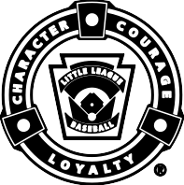
WARNING — It is important that parents/guardians and players note that: Protective equipment cannot prevent all injuries a player might receive while participating in baseball/softball.

To expedite league personnel’s reporting of injuries, we have prepared guidelines to use as a checklist in completing reports. It will save time -- and speed your payment of claims.

The National Union Fire Insurance Company of Pittsburgh, Pa. (NUFIC) Accident Master Policy acquired through Little League® contains an “Excess Coverage Provision” whereby all personal and/or group insurance shall be used first.

The Accident Claim Form must be fully completed, including a Social Security Number, for processing.
To help explain insurance coverage to parents/guardians refer to What Parents Should Know on the internet that should be reproduced on your league’s letterhead and distributed to parents/guardians of all participants at registration time.

If injuries occur, initially it is necessary to determine whether claimant’s parents/guardians or the claimant has other insurance such as group, employer, Blue Cross and Blue Shield, etc., which pays benefits. (This information should be obtained at the time of registration prior to tryouts.) If such coverage is provided, the claim must be filed first with the primary company under which the parent/guardian or claimant is insured.

When filing a claim, all medical costs should be fully itemized and forwarded to Little League International. If no other insurance is in effect, a letter from the parent/guardian or claimant’s employer explaining the lack of group or employer insurance should accompany the claim form.

The NUFIC Accident Policy is acquired by leagues, not parents, and provides comprehensive coverage at an affordable cost. Accident coverage is underwritten by National Union Fire Insurance Company of Pittsburgh, a Pennsylvania Insurance company, with its principal place of business at 175 Water Street, 18th Floor, New York, NY 10038. It is currently authorized to transact business in all states and the District of Columbia. NAIC Number 19445.This is a brief description of the coverage available under the policy. The policy will contain limitations, exclusions, and termination provisions. Full details of the coverage are contained in the Policy. If there are any conflicts between this document and the Policy, the Policy shall govern.

The current insurance rates would not be possible without your help in stressing safety programs at the local level. The ASAP manual, League Safety Officer Program Kit, is recommended for use by your Safety Officer.

TREATMENT OF DENTAL INJURIES

Deferred Dental Treatment for claims or injuries occurring in 2002 and beyond: If the insured incurs injury to sound, natural teeth and necessary treatment requires that dental treatment for that injury must be postponed to a date more than 52 weeks after the date of the injury due to, but not limited to, the physiological changes occurring to an insured who is a growing child, we will pay the lesser of the maximum benefit of $1,500.00 or the reasonable expense incurred for the deferred dental treatment. Reasonable expenses incurred for deferred dental treatment are only covered if they are incurred on or before the insured’s 23rd birthday. Reasonable Expenses incurred for deferred root canal therapy are only covered if they are incurred within 104 weeks after the date the Injury is sustained.

CHECKLIST FOR PREPARING CLAIM FORM

- Print or type all information.

- Complete all portions of the claim form before mailing to our office.

- Be sure to include league name and league ID number.

PART I - CLAIMANT, OR PARENT(S)/GUARDIAN(S), IF CLAIMANT IS A MINOR

- The adult claimant or parent(s)/guardians(s) must sign this section, if the claimant is a minor.

- Give the name and address of the injured person, along with the name and address of the parent(s)/guardian(s), if claimant is a minor.

- Fill out all sections, including check marks in the appropriate boxes for all categories. Do not leave any section blank. This will cause a delay in processing your claim and a copy of the claim form will be returned to you for completion.

- It is mandatory to forward information on other insurance. Without that information there will be a delay in processing your claim. If no insurance, written verification from each parent/spouse employer must be submitted.

- Be certain all necessary papers are attached to the claim form. (See instruction 3.) Only itemized bills are acceptable.

- On dental claims, it is necessary to submit charges to the major medical and dental insurance company of the claimant, or parent(s)/guardian(s) if claimant is a minor. “Accident-related treatment to whole, sound, natural teeth as a direct and independent result of an accident” must be stated on the form and bills. Please forward a copy of the insurance company’s response to Little League International. Include the claimant’s name, league ID, and year of the injury on the form.

PART II - LEAGUE STATEMENT

- This section must be filled out, signed and dated by the league official.

- Fill out all sections, including check marks in the appropriate boxes for all categories. Do not leave any section blank. This will cause a delay in processing your claim and a copy of the claim form will be returned to you for completion.

IMPORTANT: Notification of a claim should be filed with Little League International within 20 days of the incident for the current season.

For Local League Use Only
Activities
/Reporting

A Safety Awareness Program’s Incident/Injury Tracking Report

League Name:
League ID
Incident Date:

Field Name/Location: Incident Time:

Injured Person’s Name: Address: City: State ZIP: Parent’s Name (If Player):
Date of Birth: Age: Sex: □ Male □ Female Home Phone: ( ) Work Phone: ( )

Parents’ Address (If Different):
Incident occurred while participating in:
A.) □ Baseball □ Softball □ Challenger □ TAD
City

B.) □ Challenger □ Minor □ Major □ Intermediate (50/70)
Junior (13-14)
Big League (16-18)
(5-8)
(7-12)
(4-7)
(13-16)
(7-11)
(15-18)
(9-12)
(11-13)
T-Ball
Senior
□

- Junior □
Senior (14-16)
(12-14)
Big League

C.) □ Tryout □ Practice □ Game □ Tournament □ Special Event
- Travel to □ Travel from □ Other (Describe):
Position/Role of person(s) involved in incident:

D.) □ Batter | □ Baserunner | □ Pitcher | □ Catcher | □ First Base | □ Second
□ Third | □ Short Stop | □ Left Field | □ Center Field | □ Right Field | □ Dugout
□ Umpire □ Coach/Manager □ Spectator □ Volunteer □ Other:
Type of injury:

Was first aid required? □ Yes □ No If yes, what:

Was professional medical treatment required? □ Yes □ No If yes, what: (If yes, the player must present a non-restrictive medical release prior to to being allowed in a game or practice.)

Type of incident and location:
A.) On Primary Playing Field  □ Base Path: □ Running or | □ Sliding |  | B.) Adjacent to Playing Field  □ Seating Area | D.) Off Ball Field  □ Travel:
□ Hit by Ball: □ Pitched or | □ Thrown or | □ Batted | □ Parking Area | □ Car or □ Bike or
□ Collision with: □ Player or | □ Structure |  | C.) Concession Area | □ Walking
□ Grounds Defect |  |  | □ Volunteer Worker | □ League Activity
- Other: □ Customer/Bystander □ Other:
Please give a short description of incident:

Could this accident have been avoided? How:
This form is for local Little League use only (should not be sent to Little League International). This document should be used to evaluate potential safety hazards, unsafe practices and/or to contribute positive ideas in order to improve league safety. When an accident occurs, obtain as much information as possible. For all Accident claims or injuries that could become claims to any eligible participant under the Ac- cident Insurance policy, please complete the Accident Notification Claim form available at http://www.littleleague.org/Assets/forms_pubs/ asap/AccidentClaimForm.pdf and send to Little League International. For all other claims to non-eligible participants under the Accident policy or claims that may result in litigation, please fill out the General Liability Claim form available here: http://www.littleleague.org/As- sets/forms_pubs/asap/GLClaimForm.pdf.
This form is for Little League purposes only, to report safety hazards, unsafe practices and/or to contribute posi- tive ideas in order to improve league safety. When an accident occurs, obtain as much information as possible. For all claims or injuries which could become claims, please fill out and turn in the official Little League Baseball Accident Notification Form available from your league president and send to Little League Headquarters in Williamsport (Attention: Dan Kirby, Risk Management Department). Also, provide your District Safety Officer with a copy for District files. All personal injuries should be reported to Williamsport as soon as possible.

Prepared By/Position: Signature:
Phone Number: ( ) Date:

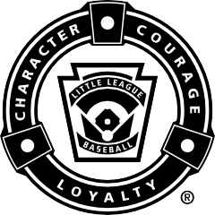
Little League® Baseball and Softball
M E D I C A L R E L E A S E

NOTE: To be carried by any Regular Season or Tournament
Team Manager together with team roster or International Tournament affidavit.

Player: Date of Birth: Gender (M/F):

Parent (s)/Guardian Name: Relationship:

Parent (s)/Guardian Name: Relationship:

Player’s Address: City: State/Country: Zip:

Home Phone: Work Phone: Mobile Phone:

PARENT OR LEGAL GUARDIAN AUTHORIZATION: Email:

In case of emergency, if family physician cannot be reached, I hereby authorize my child to be treated by Certified Emergency Personnel. (i.e. EMT, First Responder, E.R. Physician)

Family Physician: Phone:

Address: City: State/Country:

Hospital Preference:

Parent Insurance Co: Policy No.: Group ID#:

League Insurance Co: Policy No.: League/Group ID#:

If parent(s)/legal guardian cannot be reached in case of emergency, contact:

Name | Phone | Relationship to Player
Name | Phone | Relationship to Player

Please list any allergies/medical problems, including those requiring maintenance medication. (i.e. Diabetic, Asthma, Seizure Disorder)
Medical Diagnosis | Medication | Dosage | Frequency of Dosage

Date of last Tetanus Toxoid Booster:

The purpose of the above listed information is to ensure that medical personnel have details of any medical problem which may interfere with or alter treatment.

Mr./Mrs./Ms.
Authorized Parent/Guardian Signature Date:

FOR LEAGUE USE ONLY:

League Name: League ID:

Division: Team: Date:

WARNING: PROTECTIVE EQUIPMENT CANNOT PREVENT ALL INJURIES A PLAYER MIGHT RECEIVE WHILE PARTICIPATING IN BASEBALL/SOFTBALL.
Little League does not limit participation in its activities on the basis of disability, race, color, creed, national origin, gender, sexual preference or religious preference.

It is suggested this memo should be reproduced on your league’s letterhead over the signature of your president or safety officer and distributed to the parents of all participants at registration time.

WARNING: Protective equipment cannot prevent all injuries a player might receive while participating in Baseball / Softball.
WHAT PARENTS SHOULD KNOW ABOUT LITTLE LEAGUE® INSURANCE
The Little League Insurance Program is designed to afford protection to all participants at the most economical cost to the local league. The Little League Player Accident Policy is an excess coverage, accident only plan, to be used as a supplement to other insurance carried under a family policy or insurance provided by an employer. If there is no primary coverage, Little League insurance will provide benefits for eligible charges, up to Usual and Customary allowances for your area. A $50 deductible applies for all claims, up to the maximum stated benefits.

This plan makes it possible to offer exceptional, affordable protection with assurance to parents that adequate coverage is in force for all chartered and insured Little League approved programs and events.

If your child sustains a covered injury while taking part in a scheduled Little League Baseball or Softball game or practice, here is how the insurance works:

- The Little League Baseball and Softball accident notification form must be completed by parents (if the claimant is under 19 years of age) and a league official and forwarded directly to Little League Headquarters within 20 days after the accident. A photocopy of the form should be made and kept by the parent/claimant. Initial medical/dental treatment must be rendered within 30 days of the Little League accident.
- Itemized bills, including description of service, date of service, procedure and diagnosis codes for medical services/ supplies and/or other documentation related to a claim for benefits are to be provided within 90 days after the accident. In no event shall such proof be furnished later than 12 months from the date the initial medical expense was incurred.
- When other insurance is present, parents or claimant must forward copies of the Explanation of Benefits or Notice/ Letter of Denial for each charge directly to Little League International, even if the charges do not exceed the deductible of the primary insurance program.
- Policy provides benefits for eligible medical expenses incurred within 52 weeks of the accident, subject to Excess Coverage and Exclusion provisions of the plan.
- Limited deferred medical/dental benefits may be available for necessary treatment after the 52-week time limit when:
  - Deferred medical benefits apply when necessary treatment requiring the removal of a pin /plate, applied to transfix a bone in the year of injury, or scar tissue removal, after the 52-week time limit is required. The Company will pay the Reasonable Expense incurred, subject to the Policy’s maximum limit of $100,000 for any one injury to any one Insured. However, in no event will any benefit be paid under this provision for any expenses incurred more than 24 months from the date the injury was sustained.
  - If the Insured incurs Injury, to sound, natural teeth and Necessary Treatment requires treatment for that Injury be postponed to a date more than 52 weeks after the injury due to, but not limited to, the physiological changes of a growing child, the Company will pay the lesser of: 1. A maximum of $1,500 or 2. Reasonable Expenses incurred for the deferred dental treatment.
Reasonable Expenses incurred for deferred dental treatment are only covered if they are incurred on or before the Insured’s 23rd birthday. Reasonable Expenses incurred for deferred root canal therapy are only covered if they are incurred within 104 weeks after the date the Injury occurs.
No payment will be made for deferred treatment unless the Physician submits written certification, within 52 weeks after the accident, that the treatment must be postponed for the above stated reasons.
Benefits are payable subject to the Excess Coverage and the Exclusions provisions of the Policy.

We hope this brief summary has been helpful in providing a better understanding of the operation of the Little League insurance program.

General Liability Claim Form

Send Completed form to:
Little League Baseball and Softball 539 US Route 15 Hwy
P.O. Box 3485
Williamsport, Pennsylvania 17701-0485
(570) 326-1921 Fax (570) 326-2951

Telephone immediate notice to Little League® International CN
Insured
Name of League

Name of League Official (please print)
Position in League
Address of League Official (Street, City, State, Zip)
Phone No. (Res.)

Phone No. (Bus.)
Time and Place of Accident
Date of Accident
Accident occured at (Street, City, State, Zip)
Arising out of Operations conducted at
Was Police Report made? If yes, where?
Yes No
AM PM
Hour
League I.D. Number (Used as location code)

Description of State cause and describe facts surrounding accident (Use reverse side if needed)
Accident

(LEXINGTON USE ONLY)

Coverage Data
Who owns Premises
Person in charge of Premises
Products:
Yes
Elevator:
Yes
Limits
BI/PD: Med. Pay: None Policy Number

Is there any other insurance applicable to this risk?
Yes No

Policy Dates: Begin:

End:

Yes
Cont:

Property  Damage | Name of Owner | Description of Property
 | Address (Street, City, State, Zip) | Name of Insurance Co.
 |  | Nature and Extent of Damages and Estimate of Repair
Insured Person and Injuries | Name | Phone No. (Res)
 | Address (Street, City, State, Zip) | Occupation | Age | Married  Single
 |  | Phone No. (Bus)
Employers Name and Address

Did you provide or authorize medical attention? Yes No Description of Injury
Attending Doctor’s Name and Address

Witnesses: Name, Address, Phone Number
Where was the injured taken after accident?
Probable length of Disability

Name, Address, Phone Number Name, Address, Phone Number
Date of  Report: | Signature of League Official: | Position in League
USE REVERSE SIDE FOR DIAGRAM AND ANY OTHER INFORMATION OF IMPORTANCE IN REPORTING THE ACCIDENT

Applicable in Arizona
For your protection, Arizona law requires the following statement to appear on this form. Any person who knowingly presents a false or fraudulent claim for payment of a loss is subject to criminal and civil penalties.

Applicable in Arkansas, Delaware, District of Columbia, Kentucky, Louisiana, Maine, Michigan, New Jersey, New Mexico, New York, North Dakota, Pennsylvania, South Dakota, Tennessee, Texas, Virginia and West Virginia
Any person who knowingly and with intent to defraud any insurance company or another person, files a statement of claim containing any materially false information, or conceals for the purpose of misleading, information concerning any fact, material thereto, commits a fraudulent insurance act, which is a crime, subject to criminal prosecution and [NY: substantial] civil penalties. In DC, LA, ME, TN and VA, insurance benefits may also be denied.

Applicable in California
For your protection, California law requires the following to appear on this form: Any person who knowingly presents a false or fraudulent claim for payment of a loss is guilty of a crime and may be subject to fines and confinement in state prison.
Applicable in Colorado
It is unlawful to knowingly provide false, incomplete, or misleading facts or information to an insurance company for the purpose of defrauding or attempting to defraud the company. Penalties may include imprisonment, fines, denial of insurance, and civil damages. Any insurance company or agent of an insurance company who knowingly provides false, incomplete, or misleading facts or information to a policy holder or claimant for the purpose of defrauding or attempting to defraud the policy holder or claimant with regard to a settlement or award payable from insurance proceeds shall be reported to the Colorado Division of Insurance within the Department of Regulatory Agencies.

Applicable in Florida and Idaho

Any person who Knowingly and with the intent to injure, Defraud, or Deceive any Insurance Company Files a Statement of Claim Containing any False, Incomplete or Misleading information is Guilty of a Felony.*
* In Florida - Third Degree Felony
Applicable in Hawaii
For your protection, Hawaii law requires you to be informed that presenting a fraudulent claim for payment of a loss or benefit is a crime punishable by fines or imprisonment, or both.

Applicable in Indiana

A person who knowingly and with intent to defraud an insurer files a statement of claim containing any false, incomplete, or misleading information commits a felony.

Applicable in Minnesota
A person who files a claim with intent to defraud or helps commit a fraud against an insurer is guilty of a crime.

Applicable in Nevada

Pursuant to NRS 686A.291, any person who knowingly and willfully files a statement of claim that contains any false, incomplete or misleading information concerning a material fact is guilty of a felony.

Applicable in New Hampshire

Any person who, with purpose to injure, defraud or deceive any insurance company, files a statement of claim containing any false, incomplete or misleading information is subject to prosecution and punishment for insurance fraud, as provided in RSA 638:20.
Applicable in Ohio
Any person who, with intent to defraud or knowing that he/she is facilitating a fraud against an insurer, submits an application or files a claim containing a false or deceptive statement is guilty of insurance fraud.
Applicable in Oklahoma

WARNING: Any person who knowingly and with intent to injure, defraud or deceive any insurer, makes any claim for the proceeds of an insurance policy containing any false, incomplete or misleading information is guilty of a felony.

ACORD 3 (2006/02)

A practical approach to leadership responsibility in an effective Little League Safety Program

Play It Safe
Little League® Baseball & Softball

Play It Safe

FOREWORD
CONTENTS
Play it Safe 4.1
Safety is a Responsibility 4.1
Defining Terms 4.2
Structure of a Sound Program 4.2
Administration 4.3
Organization 4.4
District Safety Officer 4.5
League Safety Officer 4.6
Controls are Essential 4.7
Exposure to Unsafe Practices 4.9
Hazards in Travel To and From Field 4.13
Making Use of Accident Reporting 4.15
First Aid 4.16
Public Liability 4.16
Accident Insurance Coverage 4.18
Safety Code for Little League 4.19
As a spirited action program of established benefit to chil- dren, the movement of Little League Baseball is well known to the public and is identified with the highest standards of integrity and ethical practices consistent with the physical and emotional well-being of youngsters.
One of the important responsibilities of adults who come forward voluntarily to help is to project Little League sensibly and safely for the ultimate enjoyment of the many thousands of children who come into the local ranks
each year.
It is hoped that this book will contribute to better under- standing, and appreciation of the continuing necessity for making Little League a safe, wholesome activity. It is tailored for a wide range of interest — local league person- nel, the parent and all segments of the community which share a common objective of improving the safety factor in all sports.

Copyrighted 1998 by Little League Baseball®, Incorporated Williamsport, Pennsylvania
CC
00
U
UR
RA
G E
RPIS1

®

Play It Safe
PLAY IT SAFE

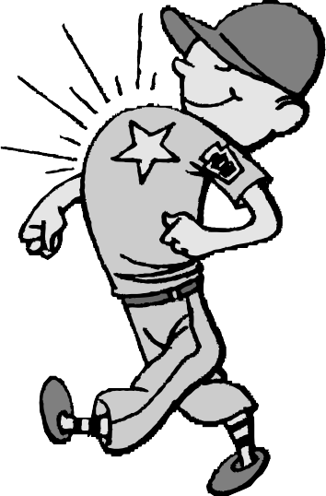
The purpose of “Play It Safe” is to provide information and counsel to Little League per- sonnel on carrying out basic safety policies, and making Little League a safer and more enjoyable activity.
Those who are engaged in Little League administration and management should have an understanding of how fundamen- tals of safety can be applied to various assignments in the organization.
Safety practices should become routine discipline and a background reason for all activities. In
short, become “safety-minded.”
The four cornerstones for building an effective safety program, known as the four “E’s” of safety, may be described as follows:
EDUCATION refers to the important matter of including suitable safety precautions in instruc- tions, training, communications, drill work and follow-up.
EQUIPMENT applies to the safe upkeep and use of physical property, fields, personal protective equipment, bleachers, bats, balls, etc.
ENTHUSIASM is the key to selling this impor- tant ingredient called safety, which can prevent
painful and disabling accidents.
ENFORCEMENT should be applied more as an incen- tive for skillful ball playing rather than as disciplinary
action. Far better results can be obtained by praise and recognition than by forcing players into line. Tactful guidance must be backed by firmness and justly used discipline.

SAFETY IS A RESPONSIBILITY

In order to understand the reasons for a Safety Program, we should look at why Little League has been so successful.

Little League Policy
One of the reasons for Little Leagues’ wide acceptance and phenomenal growth is that it fills an important need in our free society. As our program expands, it takes, more and more, a major part in the development of young people. It instills con- fidence and an understanding of fair play and the rights of other people.
Many of the younger children who develop slower than oth- ers are given an opportunity not only to develop their playing skill but to learn what competition and sportsmanship are all about. All who take part in the program are encouraged to develop a high moral code along with their improvement in physical skills and coordination. These high aims of Little League are more for the benefit of the great majority of chil- dren rather than the few who would otherwise come to the top in any competitive athletic endeavor.

Safety Responsibility
The very fact that it is a basic principle of Little League to provide an opportunity for most of the youngsters who sign up for a team to receive these benefits, multiplies the exposure to accidental injury. Having accepted this large group of partly developed fledglings, we must also accept the moral responsi- bility for their safety. This obligation rests with every adult member of the league organization as well as with inactive par- ents who have entrusted their children to us.

Other Reasons
In addition to our basic moral responsibility, other significant reasons for an organized effort to prevent accidents are to:
- Stimulate public confidence in this high caliber youth program.
- Hold insurance costs to a minimum.
- Reassure parents as to the safety of their children.
- Develop safety-mindedness for their protection in later life.

November 1997

4.3

Play It Safe
DEFINING TERMS

To clarify the meaning of these guidelines, we are defining use of the terms essential to an understanding of a basic accident-prevention program in Little League Baseball.
They are as follows:
  - ACCIDENT is a sudden, undesirable and unplanned occurrence often resulting in bodily injury, disability and/or property damage.
  - ACCIDENT CAUSE is an unsafe condition, situation or act that may result directly in or contribute to the occurrence of an accident.
  - CORRECTIVE ACTION is the positive steps or mea- sures taken to eliminate, or at least minimize, an accident cause.
  - CASE is used in the general sense, such as: accident case, injury case, claim case or insurance case.
  - HAZARD refers to a condition or a situation that could cause an accident.
  - INJURY is the physical harm or damage often resulting from an accident.
  - INSURANCE CLAIM refers to the right of a parent, as in the case of accident insurance to have eligible medical expenses resulting from an accidental injury connected with a game or scheduled practice paid by the appropri- ate insurance company
  - TYPE OF ACCIDENT is a phrase used to describe an unintentional, sudden incident that can be identified so effective counter measures may be taken.
Examples are: struck by, tripped, fell, collision with, caught between, etc.
  - AN UNSAFE ACT refers to unintentional human fail- ure or lack of skill that can lead to an accident. It is one of the two general accident causes, the other being an unsafe condition.
  - AN UNSAFE CONDITION is an abnormal or faulty situation or condition which may cause an accident. Its presence, particularly when an unsafe act is committed, may result in an accident.

STRUCTURE OF A SOUND PROGRAM

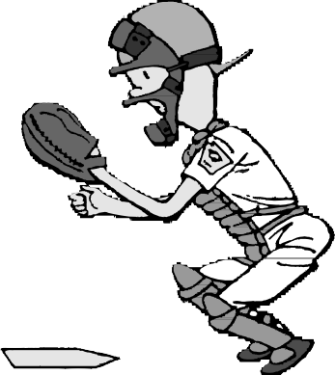
It is a recognized that the area personnel and facilities available for the operation of a Little League will dictate the structure of an effec- tive safety program. These safety
guidelines are presented as a goal toward which the adults who administer a league can work. The effectiveness of their efforts
to prevent accidents will be measured more by their sincerity of purpose than by the amount of
money and preponderance of volunteer effort at their dis- posal. Effective accident prevention is a
commodity available only to those organizations which have a real desire to make it a part of their activities.
It must be understood that although your safety pro- gram is designed to cover all personnel and all activities
in the operation of your Little League, its scope does not supersede any existing lines of authority. We
expect everyone to become “safety-minded” and be guided by safety considerations, but not attempt to change the structure of the Little League Organization.

  - November 1997

Play It Safe
ADMINISTRATION

Responsibility
The administration of an effective safety program is the responsibility of all who operate the Little League system on all levels. The inexperience and dependence of young chil- dren on adult guidance make it imperative that all levels of authority make safety an integral part of their behavior, trans- action of league affairs and instructions to the players.

Point of View
Everyone’s approach to the problem of accident prevention must be from a positive point of view if it is to be effective. We should be concerned primarily with controlling the causes of accidents which can be eliminated without taking any action, speed or competition out of the game. An attitude of alertness, hustle and enthusiasm without antagonism should be encouraged. Good equipment and proper instruction more than outweigh the risk of injury. A lively spirit of competi- tion engenders that extra effort needed for development
of skills.

Basic Factors
To minimize accidents, particularly during the initial learning period, instruction in the basic skills should be approached gradually. This applies particularly to fundamen- tals such as running, ball handling, batting and sliding which produce the majority of accidents.
A second basic factor very important to the safe develop- ment and continuing use of baseball skills is the under- standing and practice of teamwork and good sportsmanship. These intangibles have a direct bearing on accidents involv- ing another person and can be made a part of the game by the following:
- A courteous and considerate attitude by adults. They must set a good example.
- Many of the players will need to be instructed in cooper- ation between teammates and good sportsmanship toward opponents.

November 1997
4.5

Play It Safe
ORGANIZATION

Little League Headquarters
Regional Centers
District Administrator
District Safety 0fficer

Maintain continuing emphasis on accident prevention at all times.
Meetings and contacts with League Safety 0fficers to establish policy of:
- Safe playing conditions.
- Safe performance through better skills.
- Improve alertness.
- Exchange information on accident causes and their control.
League Presidents
League Safety 0fficers

Help make safety part of fun, speed and competition of game.

Coordinate safety policy in person and through meetings

Player Agents
Managers
Coaches
Umpires
Parents
Ladies Auxiliary
0ther Volunteers

L I T T L E L E A G U E P L A y E R S

The organization of your safety program is built on the two key positions of a District Safety Officer and a League Safety Officer. Their services are needed because a safety program in a large, volunteer organization such as Little League requires direction and coordination. This can be accomplished best by the efforts of conscientious individuals having accident-prevention as their main responsibility.

4.6
November 19976

Play It Safe
DISTRICT SAFETY OFFICER

The Role in Effecting a Broad Program of Safety in the District

Selection
The District Administrator should appoint a District Safety Officer (DSO) to act as a representative in carrying out the responsibility of preventing accidents in the leagues of the district.
An interested safety professional from industry, public ser- vice or the insurance field could be found who is not only qualified for this responsibility but can assist the league pres- idents in the selection of a suitable person for League Safety Officer (LSO) in each league.

Responsibilities
It is suggested the District Safety Officer hold regular meetings with League Safety Officers to assist in the follow- ing:
    - Make sure League Safety Officers are carrying out their duties as safety advisors to each team manager, coach and umpire. If each League Safety Officer cannot attend all tryouts, games or proactive sessions, a deputy or alternate should be appointed to act in this capacity.
    - Exchange information on methods that have proven most effective in the prevention of accidents in each league.
    - Review the causes of accidents that have occurred since the previous meetings in order to forestall similar mishaps elsewhere in the district.
    - For leagues carrying insurance through Little League Headquarters, the District Safety Officer will review the reporting of claims by League Safety Officers as well as a follow-up on the prompt payment of medical bills.
    - In the event that a league president has difficulty in obtaining volunteer League Safety Officers with some safety experience it is the responsibility of the District Safety Officer to train them in accepted methods of acci- dent prevention.
    - It may be beneficial to organize safety contests between teams in each league and between leagues in the district.
    - Great care must be taken to avoid the possibility of neglecting proper care of injuries to avoid having an accident charged against them.
    - The District Safety Officer, with the knowledge of the District Administrator, will also serve as liaison officer between the district and Little League Headquarters. This two-way line of communication will help the safety effort in both places. Headquarters will keep the district safety personnel informed of beneficial safety informa- tion coming from the field and other sources.
    - It is the District Safety Officer’s responsibility to see that all adults make every effort to prevent accidents before they occur rather than waiting for an unfortunate mishap to signify a safety problem.

November 19976
4.7

Play It Safe
LEAGUE SAFETY OFFICER

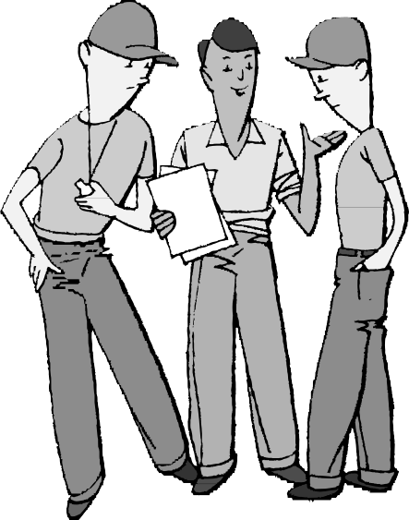Authority
By unanimous action of the 1965 Little League International Congress and subsequent ratification of the Board of Directors, it was resolved that every chartered Little League shall appoint a Safety Officer.

Selection
The league president should take great care in selecting a League Safety Officer. It would be well to interview a num- ber of people who may be qualified as outlined below. It is better to delay the selection of a League Safety Officer than to make the wrong person fit the job. Remember — the selected individual will be your personal representative on this important part of your responsibilities.

Qualifications
The League Safety Officer should be someone having the following qualifications, at least to a reasonable degree:

- Sufficient knowledge of baseball and softball to evaluate and suggest corrective measures for hazards without conflicting with Little League Rules.
- It would be an asset if that person had first hand experi- ence with a safety program, or at least an understanding of the importance of safety. Examples of people with indirect knowledge of safety would be doctors, insurance agents, and fire or police officers.
- Such an officer should be a person who can adapt a point of view to that of other volunteers. In other words, the officer should be able to sell a safety package on its own merits.
- The officer should have the interest and the time to coordinate the safety efforts of other adults in the organization.

League Safety Officer’s Authority
The League Safety Officer’s authority is mainly advisory with as much force behind advice as the league president has delegated that officer. It must be remembered that managers, player agents and umpires must carry out their own duties and responsibilities. Any differences of opinion on safety pol- icy should be referred to the League President rather than argued. Further questions may be taken up with the District Safety Officer. The latter may refer such problems to Little League Headquarters.

Responsibilities
The main responsibility of a League Safety Officer is to develop and implement the league’s safety program. The fol- lowing may help in carrying out the assigned duties.
- Spot checks should be made at practices and games to be sure reasonable precautions are taken and assist wherever possible with advice and encouragement.
- At the playing field, the League Safety Officer’s first duty is to insure first aid facilities are available and emergency arrangements have been made for an ambu- lance or doctor.
- The League Safety Officer’s next obligation is to advise and follow up on the control of unsafe conditions. These will be brought to light by the adults in charge making a preliminary inspection of the field and being continually on the lookout for situations that might cause accidents. Since it would not only be impossible, but an invitation to “buck passing,” for a League Safety Officer to keep a degree of control over accident exposures alone, such efforts will be effective only when that officer and league president have convinced fellow volunteer work- ers that safety should be a primary consideration in whatever they are doing.
- In addition to the League Safety Officer’s advising on the control of unsafe conditions throughout the season, it is a specific responsibility to follow up on procedures and methods of instruction that will help control the human elements that may be the cause of accidents. Here again the work must be done through existing lines of authority in the organization to make accident- prevention a matter of league policy rather than an after- thought applied on a hit-or-miss basis.
- It would be suitable if the League President delegates the handling of insurance claims to a League Safety Officer because:
  - A League Safety Officer will be familiar with acci- dental injury cases that require an insurance claim.
  - The personal knowledge of the people in the league will be helpful in following up on such cases.
  - The League Safety Officer will recognize the pain and hardship which result from such injuries, and will

  - November 1997

Play It Safe

serve as an additional incentive to see that everyone is kept on their toes to prevent the occurrence of other accidents.

Organized Plan
The first duty of a new League Safety Officer is to sit down with the League President and prepare a safety pro- gram for the league. It should have the essential objectives of assuring that:
    - Practice and playing field conditions are made as safe as possible.
    - Players protective equipment and other facilities are available and in good condition.
    - Arrangements have been made for first aid treatment and more severe emergencies.
    - All managers, player agents, coaches and umpires have been instructed in the inclusion of suitable safety precau- tions as an integral part of their regular duties.
    - Other volunteers, such as grounds keepers and auxiliary members are carrying out their jobs safely.
    - A definite plan is in effect for traffic safety including players travel to and from the field.
    - Arrangements are made for the prompt investigation and reporting of accidents and near-misses with a definite
follow up for the prevention of further accidents of a similar nature.
    - Procedures are in place for prompt and timely reporting of accidents requiring medical treatment to Little League Headquarters.
The best way to institute such a plan is to call a meeting of key personnel, particularly the managers and umpires. If the safety plan or program is to be effective, they must not only agree that safety is essential to the operation of their Little League, but that they will do their part to make it succeed.
They should also express a willingness to accept the help and advice of the League Safety Officer.

Incentives for Safety Officers
To people who are not familiar with the safety profession, the incentive and rewards for handling what seems to be a “thankless job” may appear to fall short of the inducements for taking other assignments in Little League Baseball. A dedicated Safety Officer gets a great deal of satisfaction from other people that they owe it to their families and themselves to be alert to prevent pain, suffering and general misfortune connected with the more severe accidents — the majority of which could be prevented. The Safety Officer’s enthusiasm for making accident-prevention work will rub off on other people in the Little League program. It is similar to the maxim that “courtesy is contagious.”

CONTROLS ARE ESSENTIAL

Having set the stage for your Little League safety program, let’s look at the control of unsafe conditions. It is a logical step, because accident causes can be controlled more readily than those involving human element.

Responsibility
The League President has the primary responsibility for safe conditions. However, it is not possible to cover all details per- sonally, so it is necessary to delegate most of this responsibility to others. The following assignments are suggested:
      - Safe maintenance of fixed ball field property, including structures, to the head groundskeeper.
      - Procurement and upkeep of practice and playing equip- ment, particularly personal protective equipment, to the equipment manager.
      - Each manager should see that the use of field and playing equipment by players does not create hazards.
      - The umpire should take the initiative to insure unsafe con- ditions are corrected on the playing field and in foul territory during games.
      - The responsibility for maintaining safe conditions for the entire league falls on the shoulders of the president. Some important safety jobs can be delegated to whomever is most suited to handle them, as follows:
November 19976
- The safety of players and adults going to and from fields is very important as shown by the severity of traffic accidents. See chapter on Traffic Safety.
- The first aid kit must be kept properly equipped and arrangements for emergencies up to date. See chapter on First Aid.
- Taking measures to counteract the hazards that may be connected with special events such as picnics, fund-raising projects, etc. See chapter on Insurance Coverage.
- The safety of spectators, including parking facilities.
- The safe handling of food and drinks at the conces- sion stand.
- If the league operates under artificial lights, the presi- dent has the very important responsibility for making sure the lights meet minimum requirements. Check with the District Administrator for Little League Lighting Standards. This is a must for safe playing conditions. The only alternative to adequate lighting is to schedule practice and games during daylight hours. Light meter checks should be made at regular intervals to find out when it is necessary to clean reflectors and replace partly worn light bulbs which have lost their original rating.
  - 4.9

Play It Safe

Physical Checkups
The physical well-being of players who are accepted in the Little League program is essential to avoid the hazard of unsafe personal conditions. It would be well to enlist the help of a local physician to advise the league on medical matters not covered by individuals’ family physicians.
It is strongly suggested that all candidates for the Little League program pass a basic physical examination before they are accepted.
Another important way that physical checkups can prevent accidents is obtaining a medical release to play ball after a player has recovered from an accident. If this final medical checkup is for evaluation of the player’s recovery from an injury covered by “accident insurance,” the cost can be charged against the original claim.

Safety Inspection
Regular safety inspection of the field, permanent and tem- porary structures, ball playing equipment and personal protective equipment is the best way to determine which unsafe conditions require correction. The managers and grounds keepers should work together to insure serious acci- dent exposures are corrected promptly! It is good experience and safety training to have the youngsters take part in the procedure.
The following list will be of assistance in determining con- ditions that cause accidents. Prompt action must be taken on all serious hazards. Some examples are:
- Unsafe field conditions such as holes, ditches, rough or uneven spots, slippery areas and long grass.
- Foreign objects like stones, broken glass, old boards, pop bottles, rakes, etc.
- Incomplete or defective screen, including holes, sharp edges and loose edges.
- Wire or link fencing should be checked regularly for similar defects which could injure a participant.
- Board fences should be free of protruding nails, loose boards, and splintered wood.
- Forty (40) feet in the center section of the outfield fence should be painted a dark color and kept free of signs to provide a contrast with balls thrown toward home.
- The warning track should be well defined and not less than 10 feet wide.
- Bat rack and on-deck* circle should be behind the screen.
- The backstop should be padded and painted green for the safety of the catcher.
- The dugout should be clean and free of debris.
- Dugouts and bleachers should be free of protruding nails and wood slivers.
- Home plate, batter’s box, bases and the area around the pitcher’s rubber should be checked periodically for trip- ping and stumbling hazards.
- Material used to mark the field should be a non- irritating white pigment (not lime). White plastic marking tape has proved better and less expensive than other methods of marking.
- Loose equipment such as bats, gloves, masks, balls, helmets, etc., must be kept off the ground.
- Constant attention must be given by managers, coaches and umpires to the possible lack or poor fit of personal protective equipment. This would include helmets, masks, catcher’s pads and safe shoes. Plastic cup sup- porters are required for regular and reserve male catchers and are recommended for all male players in addition to regular supporters.
- Personal jewelry, badges, pencils, etc., can be a hazard to the wearer and should not be permitted.

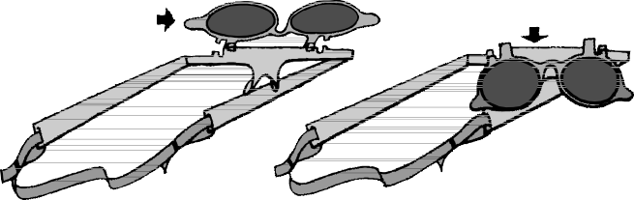
UP
DOWN
- Corrective glasses should be of the sports type and equipped with “industrial” safety lenses. Shatterproof, flip-type sun glasses are good protection against losing a fly ball in the sun.
- Bats should be inspected for orderly storage, secure grips and freedom from cracks. Cracked or broken bats should never be used.
- Safety should be the major factor when making a deci- sion on canceling a practice or game because of bad weather or darkness.
- The greatest, although the least frequent, hazard in con- nection with weather conditions is exposure to lightning. Chances of surviving being struck by light- ning are so slight that managers and umpires must not take any chances on continuing a practice or game when an electrical storm is approaching. At the first indication of such a storm, everyone should leave the playing field.
- The correct fitting and spruce appearance of uniforms has the indirect benefit of contributing to pride and morale, which stimulates our main safety objective of greater skill for fewer accidents.

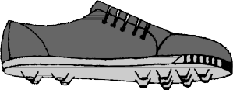
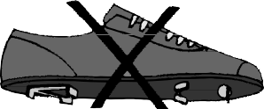
* On-deck areas have been eliminated for ages 12 and below.
  - November 1997

Play It Safe

Congestion
Congestion is one of the unsafe conditions that must be dealt with by constant supervision. The umpire will keep unauthorized people out of the way during games. The man- ager and coaches must control this hazard during practice sessions. Since the development of this hazardous condition results from unsafe acts it is covered more fully in the next chapter on that subject.

Conditioning
This important phase of Little League training has a direct bearing on developing a safe personal condition. Extensive
studies on the effect of conditioning, commonly known as “warm-up,” have demonstrated that:
- The stretching and contracting of muscles just before an athletic activity improves general control of movements, coordination and alertness.
- Such drills also help develop the strength and stamina needed by the average youngster to compete with mini- mum accident exposure.
These warm-up skills are most effective when the motions are patterned after natural baseball movements such as reach- ing for a ball, running and similar footwork. This is a good place also to “drive home” the basic safeguard of keeping the eye on the ball.

EXPOSURE TO UNSAFE PRACTICES

Unsafe acts are far more difficult to control than hazardous conditions. Also, they are the most challenging because they are involved almost entirely with the human element. It has been estimated that unsafe acts account for 80% of all acci- dents. Assuming that every effort has been made to provide safe conditions and equipment for a player, we should look at the exposure to a player’s own or someone else’s unsafe acts. Finding the causes is not enough—definite steps must be taken to counteract them.

Existing Safeguards
Before looking at these accident exposures and some sug- gestions for their control let’s look at some of the built-in safety factors that are in our favor.
  - It is obvious that non-contact sports such as baseball and track produce far fewer accidental injuries than con- tact sports like football and hockey.
  - Little League has proven the value of its playing rules and equipment requirements by the fact that each sea- son less than 2 out of 100 players have accidents resulting in injuries requiring outside medial treatment. This is far better than the average accident frequency of 6 accidents per 100 participants for school baseball players in this same age group.
  - Furthermore, 9 and 10-year-old Little League children have fewer accidents than the 11 and 12-year-olds. There are probably a number of factors that account for this difference, such as:
    - The ball is neither batted nor thrown as hard by younger players as by older ones.
    - Nine and ten-year-olds do not put in as much time actually playing ball as the older players.
    - Younger players are less easily disabled by bumps and falls than their older teammates.
With proper instruction and drill work, it is expected that most younger players will develop protective skills that will see them through the more competitive age levels of the
November 19976
game. It must be kept in mind too that some 9 and 10-year- old youngsters will develop faster and are better able to handle themselves than some 11 and 12-year-olds.

Attitude
- An attitude of alertness, hustle and enthusiasm that has been recommended as a guideline for the administration of your safety program should be carried down to all players to spark them in the development of better skills
- Good sportsmanship and courtesy, which are necessary for a harmonious and safe environment, can be taught best through the good example set by all adults on and off the field.
- Your most effective tool to inspire an attitude of self- confidence and a desire to excel is the use of much PRAISE and RECOGNITION. Of course, this must be given when deserved so as not to be cheapened by too much repetition. After all, a really good try rewarded by a word of encouragement may be a good play on the next attempt.
- Guidance on the most constructive attitude or point of view for both adults and youngsters can be summarized by recommending a POSITIVE APPROACH to all training techniques. Again, it is emphasized that good training is most effective weapon against accidents caused by unsafe acts.

Tryouts
To reduce the chances of accidents to inexperienced begin- ners, tryouts should be guided by the following:
- Players should be scheduled to report for tryouts by age groups. This will not only give the younger applicants more confidence but will reduce their exposure to the harder play of older participants.
- Since a youngster’s lack of ability to handle a ball is the most likely way for the players to get hurt, a test should be made first with some short underhand throws to
  - 4.11

Play It Safe

check skill in catching a ball before the player is exposed to normal throws or batted balls.
- Running form and speed should be observed by check- ing time and form on a dash from home plate to first base. Group racing does not exhibit true potential as a runner and could result in a pile up.
- It is better to single out a particularly awkward and inept candidate for extra attention and safe placement than to ignore flaws hoping the applicant will quit. What may be an unsafe situation is often made worse by not acknowledging it.
- The same principle of taking precautions to protect untried beginners dictates the use of great care in deliv- ering a pitched ball to a potential batter. It may be that player’s first experience.

Warm-Up Drills
The subject of warming up before a practice session has been covered as a means of safeguarding youngsters, at least to a degree, from poor physical condition and lack of limber- ing up.
Use of the term “warming-up drills,” in connection with unsafe acts, refers to ball handling practice rather than calis- thenics. This involves a serious accident exposure to misdirected balls. The following will reduce the danger of being struck by a misdirected ball:
- All unauthorized people should remain off the field during drills.
- After the number of targets has been reduced to mini- mum, one of the best preventive measures is to stress that the eye must be kept on the ball. This safe practice should be drilled into both adults and youngsters so continuously that it becomes a reflex action.
- Another danger from misdirected balls is the exposure of inexperienced batters to wild pitchers. The use of batter’s helmets is a must. However, it does not justify permitting a potential pitcher throwing to an inexperi- enced batter until control is demonstrated.
- The danger of being struck by a ball can be further min- imized by the following plan:
  - Throwing and catching drills should be set up with players in two lines facing one another.
  - Random throwing should be permitted only to desig- nated players.

Safe Ball Handling
- Misjudging the flight of a batted ball may be corrected by drilling with flys which begin easy and made more difficult as a player’s judgment and skill improves. Everyone should eventually be able to handle balls that go overhead.
- In addition to a player never losing sight of a ball from the time it leaves the bat, the player should keep the
glove positioned and the body relaxed for a last split- second move.
- An infielder can best be protected by an aggressive short-hop fielding play by always keeping the “nose pointed at the ball” and the eyes glued on it. Also, if moving forward, the player is in a better position to make a throw.
- It is safer for the player to knock a ball down and rehandle it then to let the ball determine the play.

Collisions
Collisions result in more injuries than is the case with most other types of accidents. They are usually caused by errors of judgment or lack of teamwork between fielders. It is impor- tant to establish zones of defense to avoid collisions between players. It is particularly important when players are chasing high fly balls. Once the zones are established, play situation drills should be held until these zones and patterns become familiar to the players. The responsible player should call out the intentions in a loud voice to warn others away. Here are some general rules to follow:
- The fielder at third base should catch all balls which are reachable and are hit between third and the catcher.
- The fielder at first base should catch all balls reachable which are hit between second and the catcher.
- The shortstop should call all balls reachable which are hit behind third base.
- The fielder at second base should catch all balls reach- able which are hit behind first base.
- The shortstop has the responsibility for fly balls hit in the center of the diamond and in the area of second base. Since the glove is on the left hand it is easier for the shortstop than the fielder at second to catch fly balls over second base.
- The centerfielder has the right of way in the outfield and should catch all balls which are reachable. Another player should take the ball if it is seen that it is not reachable by the centerfielder.
- Outfielders should have priority over infielders for fly balls hit between them.
- Priorities are not so easy to establish on ground balls, but most managers expect their base player to field all ground balls they can reach, cutting in front of the shortstop on slow hit grounders.
- The catcher is expected to field all topped and bunted balls which can be reached except when there is a force play or squeeze play at home plate.

Warning Track
In addition to collisions between players, occasionally a player chasing a fly ball will crash into the fence. These acci- dents also can be controlled by suitable drill work. In this case it is simply a matter of giving the outfielders an

  - November 1997

Play It Safe

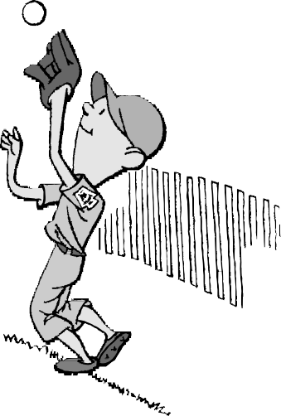
opportunity to prac- tice getting the feel of the warning track under their feet.
They must learn to judge their distance from the fence and the probable point where the ball will come down. It would be worse than futile to not only miss catching the ball by a wide margin but also be injured by a collision with
the fence.

Retrieving Balls
Balls that go out of the park should be retrieved by persons who have been specifically assigned to that duty. Such per- sons should be youngsters who can be relied on not to endanger themselves by climbing fences or getting into a scramble for possession of a ball.

Keep Grounds Clear
Another duty that should be given in turn to alert substitute players is the picking up of bats and proper placement in the rack. The clearing up of other loose playing equipment should be included in this assignment.

Sliding Safety
As is the case with other baseball fundamentals, a correct slide is also a safe one. It is well, too, to guard against the accident of a collision and the possibility of a player being struck by a thrown ball as that player “hits the dirt.” It goes without saying that steel spikes are not being worn. The fol- lowing can make the learning period safer:

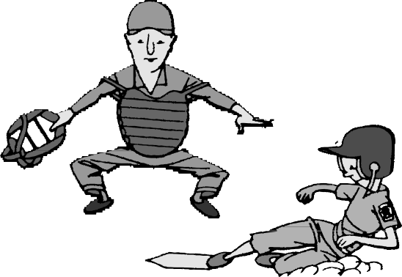
    - Long grass has been found to be better than a sand or sawdust pit to teach sliding.
    - The base must not be anchored down.
    - Sliding pads are recommended.
    - The player should make approaches at half speed and
November 1997
keep constantly in mind that hands and feet should be in the air. Once committed to slide, the player must not change strategy. Last minute hesitation causes most sliding injuries.
    - Tennis shoes are suggested for beginning sliding and tagging practice to avoid injury to the defensive player.
    - If the ground along the baselines becomes soft on a rainy day, such weather offers an excellent opportunity to have sliding drills.
    - It should be kept in mind that head-first sliding* is not recommended except when returning to a base.

Batter Safety
A batter’s greatest accident exposure is from the unsafe acts of others, namely wild pitches, which account for a major portion of all accidents. Again, the best defense is an alert, confident concentration on the ball. This type of injury is more prevalent in Regular than in Minor League play.
Since the danger is increased as pitchers learn to throw with greater force and as more games are played, it is doubly important to take whatever counter measures necessary to offset this exposure.
- A well-fitted, NOCSAE approved helmet is the first requirement.
- The development of the novice batter’s ability to take evasive action can be improved by getting the player to relax and concentrate on the ball from the time the pitcher starts delivery until it lands in the catcher’s mitt. Players with slow reflexes can also be helped by stimu- lated batting and ducking practice with a tennis ball.
- The unsportsmanlike practice of crowding the plate or jumping around to rattle the pitcher must not be toler- ated. This could endanger the batter if it causes the pitcher to lose control. Umpires should stop such actions.
- Painful finger and hand injuries can be reduced by mak- ing sure the batter holds the bat correctly when bunting. Youngsters have a tendency to lean too far over the plate and not keep the ball well out toward the end of the bat. This should be corrected.
- When the batter becomes a base runner, that player should be taught to run outside the foul lines when going from home plate to first and from third to home, to reduce the chance of being hit by a thrown ball.

Safe Handling of Bats
A review of the batter’s potential for causing injuries to others points up the following:
- The most easily prevented type of accident is the too fre- quent fault of beginners throwing the bat while running to first base. This unthinking act may be corrected

* Head-first sliding has been eliminated for ages 12 and below, except for when returning to base.
  - 4.13

Play It Safe

through individual instruction to drop the bat safely by:
- Having the player hand the bat to the coach will serve as a reminder before each ball is pitched.
- Having the player drop the bat in a marked-off circle near where running starts.
- Counting the player “out” in practice whenever the player fails to drop the bat correctly.
- Providing bats with grips that are not slippery.
- Coaches and umpires should be on the alert to correct batters that have a tendency to step into the catcher as they swing.

A Dangerous Weapon
We use this heading to note the seriousness of an accident exposure that may sound impossible but one which has caused several very serious accidents on several occasions. The preceding precautions apply to the actions of individuals who should have control over the bat they are using.
A more serious injury is waiting for the absent-minded youngster who unconsciously walks into the swing of the coach’s bat when the coach is hitting flies, or the equally unwary player who walks into the swing of a player in the on-deck circle*. These situations demonstrate the need for everyone to become safety-minded, not only for their own good but also for the safety of others. The following precau- tions are suggested:
- The player, usually a catcher, assigned to catching balls for the coach hitting flies should be given the specific assignment of warning away anyone who comes too close.
- All players and adults should be trained to walk around the on-deck circle* whether it is in use or not. The ingrained safety habit of keeping clear may save some- one a painful injury.

Catcher Safety
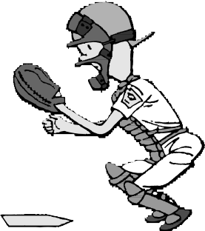
- The catcher, as might be expected from the amount of action involved has more
accidents than any other player. Statistics show that the severity of injuries is less in Regular than in Minor League play. Again, this bears out the fact that the more proficient the player, the less chance of injury. Assuming that the catcher is wearing the required protection the great-
est exposure is to the ungloved hand. The catcher must learn to:

* On-deck areas have been eliminated for ages 12 and below.
- Keep it relaxed.
- Always have the back of the throwing hand toward the pitcher when in position to catch.
- Hold all fingers in a cupped position near the mitt, ready to trap the ball and throw it.
- The catcher should also be taught to throw the mask and catcher’s helmet in the direction opposite the approach in going for a high fly.
- As the catcher learns to play this difficult position, a good habit is to keep a safe distance back from the swinging bat. Estimate this as one foot farther from the batter than the ends of the outstretched fingers.
- To repeat, the best protection is keeping the eye on the ball.

General Inattention
Going one step back to the “whys” of most ball handling accidents, it appears that inattention due to inaction or bore- dom is an underlying accident cause with which we must deal. This situation can be partly offset by using idle time to practice basics of skillful and safe play, such as:
- Otherwise idle fielders should be encouraged to “talk it up.” Plenty of chatter encourages hustle and enthusiasm.
- Players waiting for a game or practice to start can pair off and play catch to improve their basic eye-on-the ball technique.
- Practice should include plenty of variety in the drill work.
- Put a time limit on each drill and do not hold the total practice for more than two hours, or less if interest begins to lag.
- Idle players along the sidelines can be given the job of studying the form of other players to improve their own techniques. They may then report on what they have learned to improve their own form on running, ball han- dling, throwing, batting and sliding.

Control of Horseplay
No discussion of measures to control the human element in accident-prevention would be complete without going into the problem of horseplay. This includes any type of youthful highjinks that could even remotely be the cause of an acci- dent. Even a mild form of such childish behavior could distract any player about to catch a ball or possibly when at bat, and result in an accident. After all—team play requires 100% cooperation among all players, and good sportsman- ship demands courtesy to opposing players.
If show-offs and smart-alecks cannot find sufficient outlet for their high spirits in the game, quick and impartial discipli- nary action must be taken.

  - 4.14
November 19976

Play It Safe
HAZARDS IN TRAVEL TO AND FROM FIELD

Little League is also concerned for the safety of players and team officials on the way directly to and from the field. Since these adults are mature people with a good sense responsibility, it is not surprising they have had very few mishaps while going to and from their volunteer baseball jobs. Youngsters however, are likely to take a more light- hearted view of these accident exposures.
Upon examination, it is obvious that this hazard is no worse than the everyday exposure of going to and from school, the playground or elsewhere. However, this does not relieve us in the least from looking out for their safety while on Little League “business.”

Accident Exposures
A quick examination of our problem leads us to separate these exposures into two broad classifications; namely, traffic safety and the various temptations resulting from youthful curiosity and a desire for adventure. In the field of insurance law, the latter type are known as “attractive nuisances.” They range anywhere from an easy-to-climb tree to a boat that has been left without being chained and padlocked.

Travel Hazards
Although Little League traffic accidents involve only one or two cases for every hundred injuries from all accidents, the average severity of these accidents far exceeds those from other causes.
The alarming country-wide increase in all traffic accident deaths has made the publicity on these losses a natural cru- sade. This staggering annual increase indicates the public conscience has become hardened, not only to these needless fatalities but also to the tragic probability that millions will be seriously injured as the result of traffic accidents in the years to come. Too often we assume that it cannot happen to us or our loved ones until it is too late to prevent a crippling or fatal injury. In Little League we have not only an opportu- nity but an obligation to take organized action for the protection of our own interests. Let’s do something about it.

General Accident Prevention
First, let’s look at what can be done to implant the basic principles of traffic safety in the thinking of our adults and particularly our players.
    - In any meeting or gathering where adults are brought together, they should be reminded repeatedly of their respon- sibility to:
- See that all passengers use seat belts. Do not carry passengers in cargo areas of vans and pick-ups.
- See that their vehicles are in safe operating condition.
- Observe traffic regulations.
- Drive defensively.
November 1997
    - Youngsters who are walking to or from the field should be reminded by their parents, managers and coaches to:
- Not hitch rides.
- Use street or highway crossings protected by lights as much as possible.
- Always walk in single file off the roadway, and on the side against the flow of traffic where there are no sidewalks.
- Wear light-colored clothing and carry a flashlight when walking along a road after dark.
- Be just as alert to the dangers of moving traffic when in a group as when alone. Do not depend on others.
- Observe bicycle safety rules such as those listed in the next section.

Bicycle Safety
In spite of the nationwide increase in the popularity of bicycling, the number of accidents to riders has not increased as rapidly as is the case with other types of traffic accidents, thanks to the emphasis that has been placed on bike safety. It is estimated there are over 57 million bike riders in America. Still, our country is faced with hundreds of fatalities and thousands of disabling injuries each year from bicycle mishaps. We should be concerned that 4 out of 5 of these accidents are to young people in the 5 to 15 year age bracket.
Since bike riding is generally the most popular way for Little Leaguers to travel to and from the playing field, place more emphasis on bicycle traffic safety.

Bicycle Accident Prevention
As in the case of discovering and correcting the causes of player accidents, let’s examine the major causes of bike acci- dents and what can be done to offset them.
- According to the National Safety Council, 15% of all fatal bike accidents nationwide did not involve motor vehicles. In general, they were “spills” caused by:
  - Slippery or rough riding surfaces.
  - Defective bicycles.
  - Collisions with pedestrians or fixed objects.
A significant number of bicycle accidents that resulted in injuries could have been prevented by keeping the bikes in good mechanical condition, better rider skills and the obser- vance of bike safety rules.
- The remaining 85% of fatal accidents involving colli- sions between motor vehicles and bicycles were analyzed by the National Safety Council as follows:
  - One-half occurred at intersections.
  - Seven out of ten were during daylight hours.
  - Four-fifths of the cyclists killed or injured were vio- lating a traffic law.
  - 4.15

Play It Safe

They were:
- Failing to yield the right of way.
- Riding in center of street.
- Speed too fast for conditions.
- Disregard for traffic control devices.
- Riding against traffic.
- Improper turning.
  - Additional responsibility by the car drivers is indi- cated by the fact that many accidents involve violations by the auto vehicle drivers.
  - In one of five cases, the bicycle had a mechanical defect that could have caused the accident.
Since we can do very little to control violations by motor vehicle drivers it is doubly important to have some assurance that: (1) the bikes will be in good condition, including suit- able lights and reflectors; (2) the riders will be
safety-minded; and (3) they will ride defensively.
- Having decided on these four objectives, what can be done to implement our bicycle safety program without over-burdening our volunteers? First, it should be noted that the best results have been obtained by safety promo- tion projects in which the youngsters take an active part. This can be done by getting a local bike shop or a civic- minded organization to sponsor a package program such as the ones offered without charge by the Bicycle Institute of America. It is located at 122 E. 42nd Street, New York, NY 10017. They will provide not only well- tested procedures but such incentives as colorful decals for the bikes and Safety League membership rule cards. Part of the card is shown below.
- Observe all Traffic Regulations — red and green lights, one-way streets, stop signs.
- Keep to the Right — ride in a straight line. Always ride in single file.
- Have White Light on Front — danger signal on rear for night riding.
- Have Satisfactory Signaling Device to warn of approach.
- Give Pedestrians the Right-Of-Way. Avoid sidewalks — otherwise use extra care.
- Look Out for Cars Pulling Out Into Traffic. Keep sharp lookout for sudden opening of auto doors.
- Never Hitch on Other Vehicles — do not “stunt” or race in traffic.
- Never Carry Other Riders — carry no packages that obstruct vision or prevent proper control of cycle.
- Be Sure Your Brakes Are Operating Efficiently —
keep your bicycle in good running condition.
- Slow Down At All Street Intersections — look to right and left before crossing.
- Always Use Proper Hand Signals — turning and
- Don’t Weave In Or Out of Traffic — Do not swerve from side to side.
Suggested bike safety programs are:
- Safety inspection of all bikes by a qualified service mechanic.
- Testing of individual youngsters for: balance, changes in direction, traffic control, pedaling and braking, maneuvering, mounting, obstacles, emer- gency stops, turning, signaling and proper care of bike.
- Rodeo, which is similar to the testing program except that the participants are scored on their knowledge of bike safety and execution of various maneuvers while competing for prizes. This could be made more excit- ing by having the various teams in each league compete against each other.
4. Another effective way to impress youngsters with the importance of observing traffic safety rules is to have a safety representative from your local law enforcement agency talk briefly to each Little League group, follow- ing a practice or game. Youngsters may be impressed by the importance of traffic safety rules which are explained by an officer, such as a state trooper, in uniform.

Prevention of Other Going-and-Coming Accidents
As mentioned at the beginning of this chapter, our Little Leaguers are exposed to other accidents while traveling to and from the ball field.
These accidents, which can be very serious, are a difficult type to prevent. The youngsters are usually out of touch with adult guidance when they get an impulse to climb a tree, throw a stone, watch a construction job, try out someone’s motor bike, play in the water or otherwise express their nat- ural curiosity and spirit of adventure. Unfortunately, some of their impulsive actions have led to disastrous results.

Possible Preventative Measures
- The most positive approach, and probably the most effective, is appealing to their loyalty to the Little League uniform or cap. Parents, managers and coaches should impress upon them that their behavior along the way will give other people a good or bad impression of Little League, depending on how they act.
- Youngsters should also feel the restraining effect of orders to go directly to the field and report to their man- ager or coach. The same order should apply to going straight home and checking-in with their parents.
- As an indirect precaution, parents should be encouraged to have their youngsters learn how to swim. This is par- ticularly important if there are any bodies of water within striking distance of their route. This knowledge

  - 4.16
stopping.
November 1997

Play It Safe

may save their lives when temptation is stronger than the voice of authority.
- A surprising number of accidents also occur when youngsters reach the vicinity of the field but it is not yet time for practice or a game. In this situation it is the direct responsibility of any adults who are nearby to stop
such activities as climbing trees, chasing each other, running up and down the grandstands, etc.

- Volunteers should make local authorities aware of poten- tial risks in the area, ie. unfenced excavation or quarries and lakes with unsecured boats.

MAKING USE OF ACCIDENT REPORTING

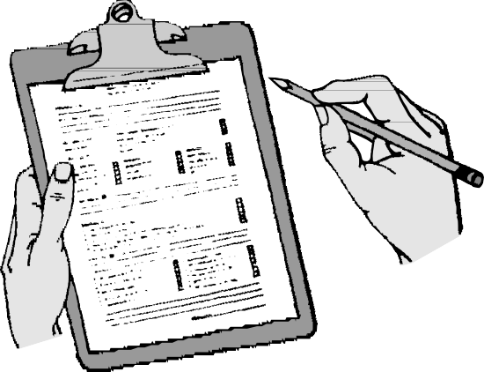
In the effort to prevent accidents to Little Leaguers one must deal with the unpredictable actions of many small ath- letes. One of the most widely accepted ways to counteract the unsafe acts, which are so often a part of such uncertain behavior, is to inquire into the reasons
behind such acts and take suitable counter measures.
Since we cannot eliminate all of these disturbing and sometimes tragic mishaps, one must use them as tools to help control similar or related accidents. Also, alert opera- tion makes it possible to get at the causes of “near misses” so that something can be done to prevent the occurrence of injury-producing accidents.

Which Accidents to Analyze
Good judgment must be used in deciding which accidents to analyze. The severity of an injury should not be the only basis of deciding to determine reasons for an accident and what can be done to reduce the chances of its reoccurrence. The possibility of a similar and more severe accident occur- ring should be our main reason for getting at the causes and taking suitable corrective action.
Examples of cases that probably would not require detailed checking would be a “strawberry” from sliding or minor strains and bruises, not associated with serious unsafe acts or conditions.

Examples of accidents requiring thorough study are:
  - A collision when two players go after the same fly ball, even though no one is hurt, has the possibility of result- ing in a serious injury. Questioning players may reveal they had forgotten ball priority assignments in the excitement of trying to make the catch. The corrective measure might be to hold additional ball priority drills. A completed accident cause report passed on to the Safety Officer will serve as a warning to managers of other teams.
  - If a player should trip and fall over a bat left on the ground and suffer a small abrasion, the cause and
November 19976
correction of this type of accident may be obvious. A report, however, would serve as a reminder, not only to this team, but to others in the league that equipment left on the field can cause falls, some of which can result in fractures.
  - Although it may be embarrassing to a manager, should a relief catcher have front teeth knocked out because of neglect to always wear a mask and
catcher’s helmet when warming up a pitcher, the report on such a viola- tions should be passed along as a
warning to others.
  - Let’s assume a player turns an ankle chasing a fly ball. Upon checking, it is
found there is a hole in the outfield. A copy of the accident report passed on to the grounds keeper
would reduce the chances of that person forgetting to correct the hazard.

Other Uses for Accident Reports
- The need for corrective measures, of course, is most evi- dent when an injury is severe enough to require professional services. In addition to the need for imme- diate preventative action, it is very important to have accurate information to complete the insurance claim report. This may be done by the Safety Officer.
- As in any organized endeavor, communications among teams in a league and leagues in a district is important. The safety program can be effective for everyone if each adult, with some safety responsibility, is given a brief report on serious or unusual hazards and the corrective action that has been taken to counteract them. In order to accomplish this, the League Safety Officers and the District Safety Officer must be kept informed about all significant accident cases.

Further Follow-Up on Accident
Even after corrective measures have been put into effect, responsible adults should continue to check back to make sure that unsafe habits have not been resumed and conditions are not allowed to slip. We advise youngsters to keep their eye on the ball. Let’s do the same with safety precautions.
  - 4.17

Play It Safe
FIRST AID

First aid is an important part of any safety program. Like insurance coverage, it is a form of protection that must be available in case of an emergency involving any injury.

Definition
First aid is the immediate, necessary, temporary, emergency care given for injuries.

Selection and Qualifications of First Aiders
It is recognized as impractical to have a completely trained and experienced first aider on duty at all times. However, every effort should be made to have several alternate first aiders, preferably adults whose duties keep them at the field, trained in the basic requirements of first aid treatment.
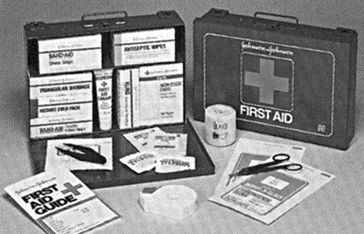Ideally, this train- ing should be from an accredited agency such as the American Red Cross. The alterna- tive is to have them trained briefly and specifically for this purpose by a med-
ical doctor or a registered nurse who is familiar with Little League operations. Minimum first aid training should include the handling of extreme emergencies such as the usage of mouth-to-mouth resuscitation and external cardiac massage.

First Aid Equipment
Since this chapter of “Play It Safe” is not intended as a First Aid Manual, we have omitted information on treatment. Both this and the proper equipping of the first aid kit should be left to the advice of local medical authorities. It is sug-
gested, however, that in addition to the stock of bandages and medication, the following be available:
- A supply of clean water, soap and towels
- A blanket
- Arm and leg splints
- Easily accessible phone with emergency phone numbers, such as doctor, hospital and ambulance service. If a pub- lic phone is to be used, small coins should also be readily available.

Notification of Family
It is extremely important that, as soon as provision has been made for the care of injured or ill people who require outside treatment their family be notified in as tactful a man- ner as possible.

Follow-Up on First Aid Cases
Care of an ill or injured individual must always be the first consideration. In concern for their welfare, however, do not neglect the following:
- A thorough investigation should be made to find the cause(s) of an accident and action started to prevent reoccurance.
- An insurance claim should be filed when outside med- ical attention is required. Do not wait for medical bills to arrive. They can be submitted as they become available. They must be identified by including the person’s name, league name and number, date of injury, and city and state of residence. Bills should be itemized to show dates and type of treatments.
- Any player under the care of a doctor should be required to bring a note from the doctor to the manager releasing the player to play ball before being allowed to return to the lineup.

PUBLIC LIABILITY

The responsibility of all organizations and their individual members for the safety of the general public has become an increasingly important factor in present-day society.

Little League’s Obligation
As a non-profit organization supported by public funds and operated by volunteers we should have a deep interest in the safety of the general public as well as the protection of our Little League volunteers from lawsuits.
Even though we cannot fully protect the public from all sit- uations arising out of the operation of a league, we can safeguard them from our own unintentional negligence.

Consequences of Being Sued
No matter how unjustified a liability suit may be, we should be concerned about the effects of such legal action on Little League and particularly on the men and women who make the league possible.
- The worst result of such a suit, if there is no liability insurance coverage, is the possibility of wrecking the financial position of the individual against whom the suit is directed. In cases where a large judgment is obtained against an individual, the Court may take over all of a person’s assets and even attach future earnings for years to come.

  - November 1997

Play It Safe

- Another ill effect is unfavorable publicity from news releases, which are sometimes of a sensational nature. They can damage the public good will which has taken years to build.

Protective Measures
- Obviously our best protection against the relentless attacks of a few claim-minded individuals is to have adequate liability insurance coverage from a reputable company. This will protect local league officials but not the good name of the league and its members.
- Some legal protection can be obtained by incorporating a league under the laws of the state in which it operates. This is not to be confused with Little League Baseball, Incorporated, which cannot pass the advantages of its incorporation on to individual Little Leagues. They must be incorporated under the laws of the state in which they operate.
This relatively inexpensive protection will safeguard the league as a whole and its members, to a degree, from unlimited financial responsibility for a judgment against the league. However, it will not relieve anyone from the legal expenses required to defend against a suit, nor will it limit the legal responsibility of persons who may be sued as individuals. A league desiring to use the words “Little League” in its corporate title must first obtain consent from Little League Headquarters.
- As in the case of player accidents, we can go a long way toward safeguarding the good name of Little League and the best interests of all individuals by taking a few com- mon-sense precautions.

Avoid Negligence
The taking of precautions should be based on this main objective of avoiding any implication of negligence on the part of Little League people. In most successful public liabil- ity suits, the claimant must prove that some organization or individuals have been negligent in their obligation to safe- guard the general public. Some examples of what can be considered as negligence are:
- The use of grandstands or bleachers that are unsafe due to faulty design, the use of substandard building materi- als or material which has deteriorated to a point where they are not safe for a capacity crowd.
- Spectator screen with holes which have become loose or torn.
- The serving of food at a Little League concession stand that may have become spoiled or contaminated and the careless use of bottled gas. The following safety rules should be observed if bottled gas is used for cooking:
  - Gas cylinders and regulators should be installed out of doors, at least three (3) feet from any building and, if not separated by a solid wall, at least six (6) feet
November 1997
from the gas burners. Cylinders should always be in an upright position.
  - Solid pipe, metal tubing or standard braided metal hose should be used to connect the cylinders. Pipe should have flexible couplings or a tubing loop to provide for jarring or vibration.
  - Cylinders should be installed and maintained by the supplier. By having a reserve cylinder piped up and ready for use, there will be no need for Auxiliary per- sonnel to do more than turn a valve.
  - Gas cylinders should be protected from physical damage and tampering but never in a solid enclosure, to avoid the possibility of an explosion.
  - When not in use they should always be turned off at the cylinder and the key or valve handle removed.
  - A hand fire extinguisher suitable for grease fires should be available and kept fully charged. The mini- mum requirement is a 5 lb. carbon dioxide type or a 2 3/4 lb. dry chemical extinguisher.
  - If leaking gas ignites, always shut off the valve at the cylinder. If gas is burning at the top of a cylinder, DO NOT TRY TO EXTINGUISH IT. Call the Fire Department.
  - Have your installation inspected and approved by your local Fire Protection Authorities.
- Permitting members of the general public, particularly small children on the playing field where they may be exposed to thrown or batted balls and swinging bats.
- Allowing a pitcher and catcher to warm up in an unsafe location such as too near the stands, where a wild pitch could injure someone.
- Ignoring an obvious and frequent exposure to
non-spectators using a public street or similar area and preventing their being struck by hard hit balls hit out of the playing field.

Conclusion
In brief, we can discharge our obligations for the safety of the general public and the welfare of the league and its mem- bers by:
- Providing a reasonably safe place for spectators and maintaining it in good condition. Any adult spectator in attendance assumes the normal risks of watching base- ball. Grandstand and bleachers should be inspected annually and be in conformity with National Fire Protection Association Standard for Places of Outdoor Assembly, No. 102. A pamphlet on Code No. 102 may be purchased from the NFPA, 470 Atlantic Avenue, Boston, MA. 02100. In some states, inspection service is provided and compliance with this Code is a legal requirement.
  - 4.19

Play It Safe

- Keeping an alert eye out for dangers to the general public and nonspectators in the vicinity of the field. This applies particularly to small children.
- Carrying adequate public liability insurance with a rep- utable company. Extensions of this coverage are needed
for the use of additional fields which are under other ownership.

- Have the league incorporated under the laws of the state in which it operates.

ACCIDENT INSURANCE COVERAGE

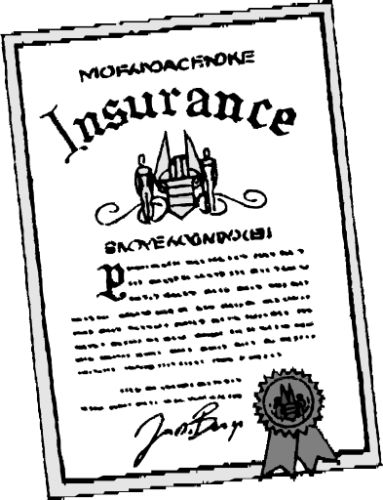
A complete safety program must be backed up by adequate accident insurance coverage. Responsible organizations pro- viding athletic programs assume a moral
obligation to assure each injured player adequate medical attention and to help parents or families of injured players by easing the burden of medical expenses. In addition, adults who volunteer to assist in the operation of the league are entitled to protection from possible costs of acciden- tal injuries.

Accident Insurance
This coverage is a requirement for char- tering a league and is not to be confused with public liability insurance described in the foregoing chapter. Liability insurance protects a Little League against suits arising out of accidents to the general public.
Adequate accident insurance provides reimbursement for actual eligible medical costs arising out of accidental injuries to eligible individuals in the Little League organization directing or assisting with the games, tournament, practices and when traveling directly to and from the field. See your League President for pamphlets that provide a detailed description of these insurance coverages.

Insurance for Service-Connected Leagues
Adequate insurance for leagues operating at military instal- lations sometimes is overlooked because of the free medical services available at these locations. Individuals in these leagues are not usually covered for:
  - The cost of dental care for dependents, if stationed in the United States.
  - The full expense of hospital care outside of military installation.
  - Injury expenses to civilian employees and their depen- dents.
  - Most accident expenses incurred in connection with baseball trips away from the military installation.
It is strongly recommended that these leagues review their insurance position and consider obtaining coverage through Little League Headquarters for:
- A special death and dismemberment policy for each team.
- Full coverage for approved tournaments if their activities will take them away from government property.
- Regular Little League insurance, if the lack of medical benefits indicate a need for this protection. This coverage would make sep- arate death and dismemberment and tournament insurance unnecessary.

Little League Insurance Obligations
The payment of premiums for insurance coverage, even the required accident insur- ance, does not completely fulfill a league’s requirement to its members. Misuse of an insurance contract may seem to provide extra benefits for the few individuals who have no scruples in this regard. In actual fact, they are only working to their own disadvantage
and that of other leagues in their rating area. Unjustified overloading of claim costs can result in increased premium charges. In time it could price your league out of business, as well as other leagues having limited finances. These abuses may be unintentional or possibly based on the fallacy that “any insurance company is fair game.” Some examples are:
- Submitting claims for injuries or illnesses that are not directly related to Little League activities.
- Concealing other insurance coverage which has a prior responsibility for the payment of a claim or permitting duplication of benefits.
- Permitting medical services to overcharge just because insurance coverage is available.
- The submission of unjustified claims by a league official who has not taken the trouble to have the essential details of an accident checked by a responsible person to make sure that it has resulted directly from a Little League activity covered by insurance.

Little League Headquarters Assistance
Little League Headquarters, with its data processing equip- ment and research analysis department, is in an excellent position to take corrective action based on a review of claim cases. These safety improvements may take the form of:
- Adjusting playing conditions.
- Developing and improving protective equipment.
- Advising on training procedures.

  - November 1997

Play It Safe

- Changing playing rules or Safety Code.
- Assisting leagues in areas where accidents are found to be excessive.

As a result of their detailed knowledge and their favorable bargaining position with large reputable insurance companies, Little League Headquarters is in the best position to adminis-
ter adequate and economical group insurance coverage for all Little Leagues. This service includes the ability to give credit through reduced premium costs in areas which have shown a consistently good experience.
Little League officers are urged to take advantage of both the insurance and accident-prevention services that are avail- able through Little League Headquarters.

SAFETY CODE FOR LITTLE LEAGUE

- Responsibility for procedures should be that of an adult member of the local league.
- Arrangements should be made in advance of all games and practices for emergency medical services.
- Managers, coaches and umpires should have some train- ing in first aid. First Aid Kit should be available at the field.
- No games or practices should be when weather or field conditions are not good, particularly when lighting is inadequate.
- Play area should be inspected frequently for holes, damage, stones, glass and other foreign objects.
- Dugouts and bat racks should be positioned behind screens.
- Only players, managers, coaches and umpires are permit- ted on the playing field during play and practice sessions.
- Responsibility for keeping bats and loose equipment off the field of play should be that of a player assigned for this purpose.
- Procedure should be established for retrieving foul balls batted out of the playing area.
- During practice and games, all players should be alert and watching the batter on each pitch.
- During warm-up drills players should be spaced so that no one is endangered by wild throws or missed catches.
- Equipment should be inspected regularly. Make sure it fits properly.
- Batters must wear approved protective helmets during batting practice, as well as during games.
- Catcher must wear catcher’s helmet, mask, throat protec- tor, long model chest protector, shin guards and male catchers must wear a protective supporter at all times.
- Except when runner is returning to a base, head first slides should be avoided.
- During slide practice bases should not be strapped down and should be located away from the base anchoring sys- tem.
- At no time should “horse play” be permitted on the play- ing field.
- Parents of players who wear glasses should be encour- aged to provide “safety glasses.”
- Players should not wear watches, rings, pins or other metallic items.
- Catchers must wear catcher’s helmet and mask with a throat protector in warming up pitchers. This applies between innings and in the bull-pen.

November 1997

  - 4.21

Good Procedures to Implement
Checklist for Managers, Coaches, and Umpires

Here are some good procedures for your league to implement and follow on several required areas of the safety plan. Requirements 7, 10, 12 and 13 are all included in the checklists below. These come from several leagues whose volunteers are providing safety leadership through their efforts to increase awareness and help volunteers do the right thing at
the right time.
- Safe Playing Areas
Regular safety inspections of all fields, (practice and game), structures, and dugouts, is the best way to eliminate conditions that cause accidents.
Managers, coaches, and umpires should routinely check playing area for:
- Holes, damage, rough or uneven spots, slippery areas, and long grass
- Glass, rocks, foreign objects
- Damage to screens or fences, including holes, sharp edges, or loose edges
- Unsafe conditions around backstop, pitcher’s mound, or warning track
- Proper attire by the catcher at all times, including in the bull pens and in between innings

- Safe Equipment
All equipment shall be inspected before each use. Regular safety inspection
of equipment is essential. Managers, coaches, and umpires should:
  - Be sure all equipment is LL approved
  - Inspect all bats, helmets, and other equipment on a regular basis. Dispose of unsafe equipment properly.
8 January-February 2004

  - Keep loose equipment stored properly
  - Have all players remove all personal jewelry
  - Parents should be encouraged to provide safety glasses for players who wear glasses
  - Repair or replace defective equipment

- Safe Procedures
Managers and coaches must:
- Have all players’ medical release forms with you at every practice and game
- Have a first aid kit with you all practices and games
- Have access to a telephone in case of emergencies
- Know where the closest emergency shelter is in case of severe weather
- Ensure warm-up procedures have been completed by all players
- Stress the importance of paying attention, no “horse playing allowed”
- Instruct the players on proper fundamentals of the game to ensure safe participation
- Each practice should have at least 2 coaches in case of an emergency

- Weather Conditions
Before the Storm
- Check the weather forecast before leaving for a game or practice
- Watch for signs of an approaching storm
- Postpone outdoor activities if storms are imminent
Approaching Thunderstorm
- Take caution when you hear thunder. If you hear thunder, you are close enough to get struck by lightening. During a game, the umpire will clear the field in the event of an approaching storm.

- Move to a safe environment immediately. Do not go under a tree or stay in the dugout.
- If lightening is occurring and there is not sturdy shelter near, get inside a hard top automobile and keep the window up.
- Stay away from water, metal pipes, and telephone lines.
- Unplug appliances not necessary for obtaining weather information. Avoid the telephone except for emergency use only.
- Turn off air conditioners.
If caught outdoors & no shelter exists
- Find a low spot away from trees, fences, light poles, and flagpoles. Make sure the site you pick is not prone to flooding.
- If in the woods, take cover under shorter trees.
- If you feel your skin begin to tingle or your hair feels like it’s standing on end, squat low to the ground, balancing on the balls of your feet. Make yourself the smallest possible target, tuck your head between
your legs, and minimize your contact with the ground.
What to do if someone is struck by lightning
- The person who has been struck will carry no electrical charge; therefore, they are safe to touch.
- Call 9-1-1 as soon as possible for help.
- Check for burns to the body.
- Give first aid as needed.
- If breathing and/or heartbeat have stopped, perform CPR until EMS arrives.
- Contact the league Safety Officer or President ASAP.

Suggestions for Warm-up Drills

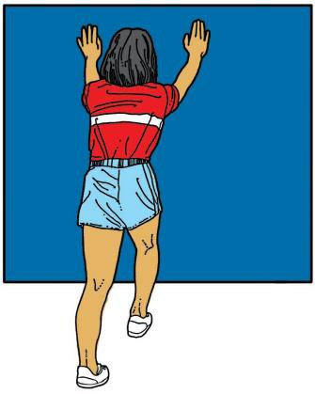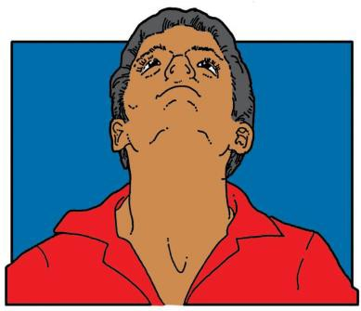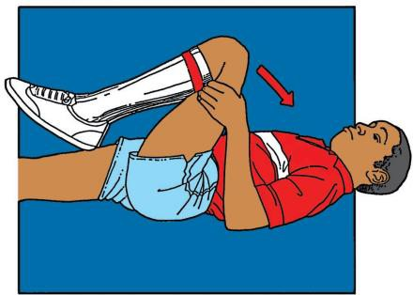

Heel Cord Stretches
Lean against a wall. Reach one leg behind you. Keep the knee straight, heel on the ground, and toes pointed forward. Slightly bend the leg that’s closer to the wall. Lean forward. You should feel the stretch along the back of your calf. Repeat with other leg.
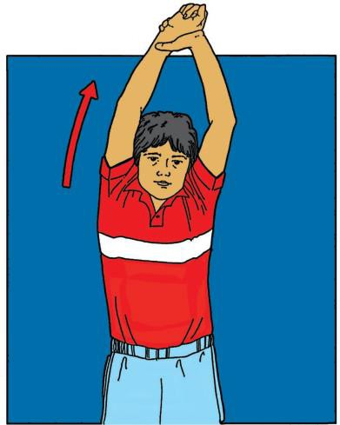
Shoulder Stretches #1
Stand or sit, holding your throwing arm at the wrist with your other hand. Put your arm over your head and pull gently, feeling your upper arm against your head. You should feel the stretch inside your shoulder.

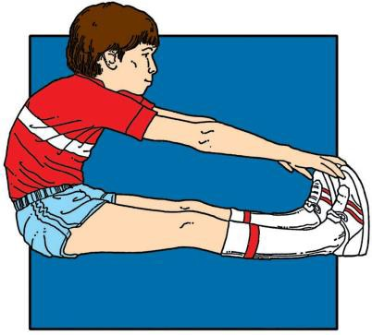
© 1998 Little League Baseball® and Musco Lighting, Inc.
Head and Neck Circles
Make a circle with your head, going around first in one direction five times. Then reverse and make five circles in the opposite direction.

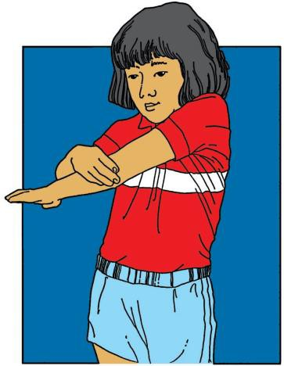
Shoulder Stretches #2
Stand or sit, holding onto the elbow of your throwing arm with your other hand. Gently pull yourthrowing armacross yourchest. You should feel the stretch inside your shoulder, especially at the back.

Thigh Stretches #1
Sit on the ground. Stretchboth legs out in front of you. Reach forward, touching your toes. Eventually, you want to lean forward far enough to put your head on you knees. You should feel the stretch along the backs of your legs.

Thigh Stretches #2
Sit on the ground with one leg stretched out in front of you. Bend the other knee and put your foot behind you. Lean backwards. You should feel the stretch along the front of your thigh.
Low Back Stretches
Lie on your back, bring one knee up, and pull the knee slowly toward your chest. Hold and repeat three times. Switch legs and repeat.

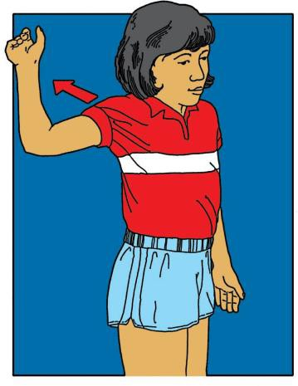
Shoulder Stretches #3
Stand or sit with your pitching arm out to the side and your elbow bent. Move your arm back until you feel the stretch in the front of your shoulder.

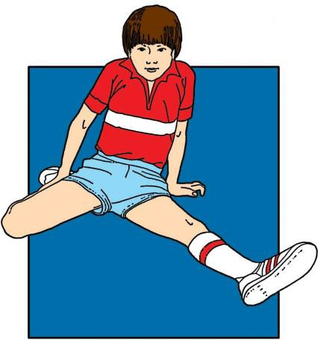

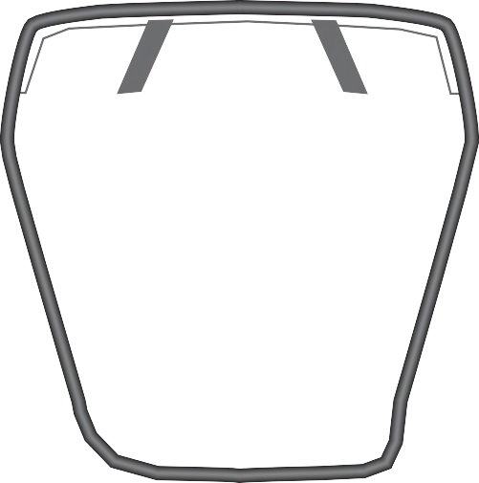

“Dangling”

REMEMBER:
Catchers must wear helmets during warm-ups and infield/outfield practice.

RULE 1.17
“...All catchers must wear a mask, ‘dangling’ type throat protector and catcher's helmet during infield/outfield practice, pitcher warm-up and games.”

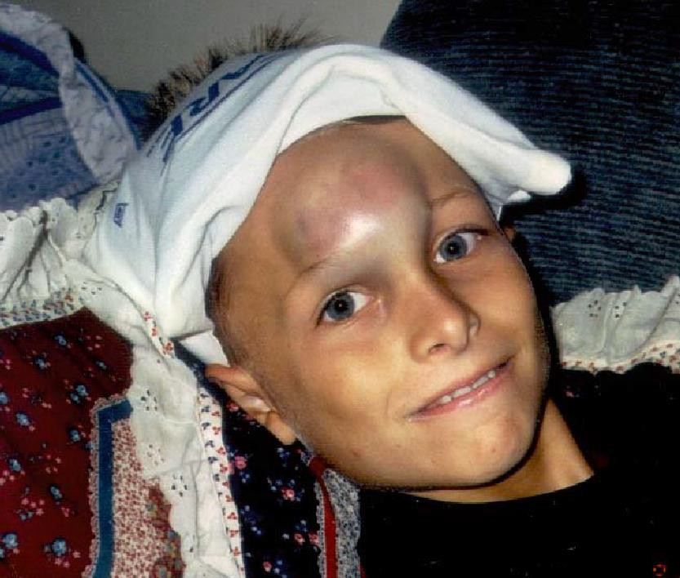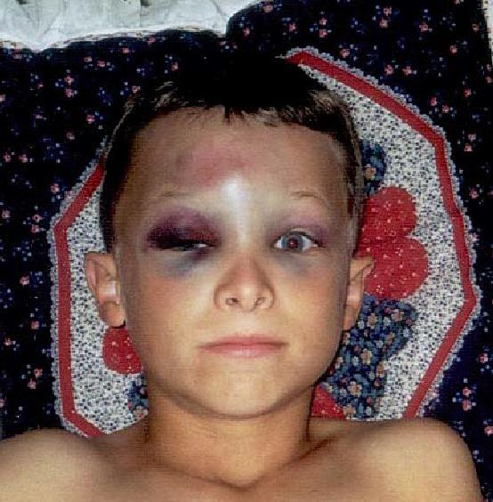
Copy and post in dugouts.

...Until You’re Up to the Plate!

(Photos from North Scott, Iowa, Little League)

Don’t let this happen to you, or to a teammate.

REMEMBER:
Don’t pick up your bat until you leave the dugout, to approach the plate.

RULE 1.08, Notes
“1. The on-deck position is not permitted in Tee Ball, Minor League or Little League (Majors) Division. 2. Only the first batter of each half-inning will be allowed outside the dugout between the half-innings in Tee Ball, Minor League or Little League (Majors) Division.”

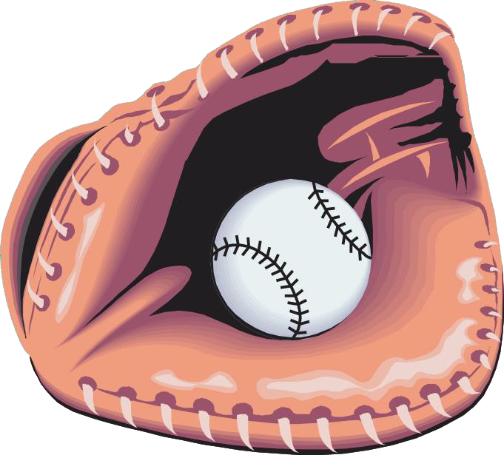
Copy and post at dugouts.

REMEMBER:
Coaches and managers must not warm up pitchers. Let Players Catch.

RULE 3.09
“...Managers or coaches must not warm up a pitcher at home plate or in the bull pen or elsewhere at any time. They may, however, stand to observe a pitcher during warm-up in the bull pen.”

6 March 2003

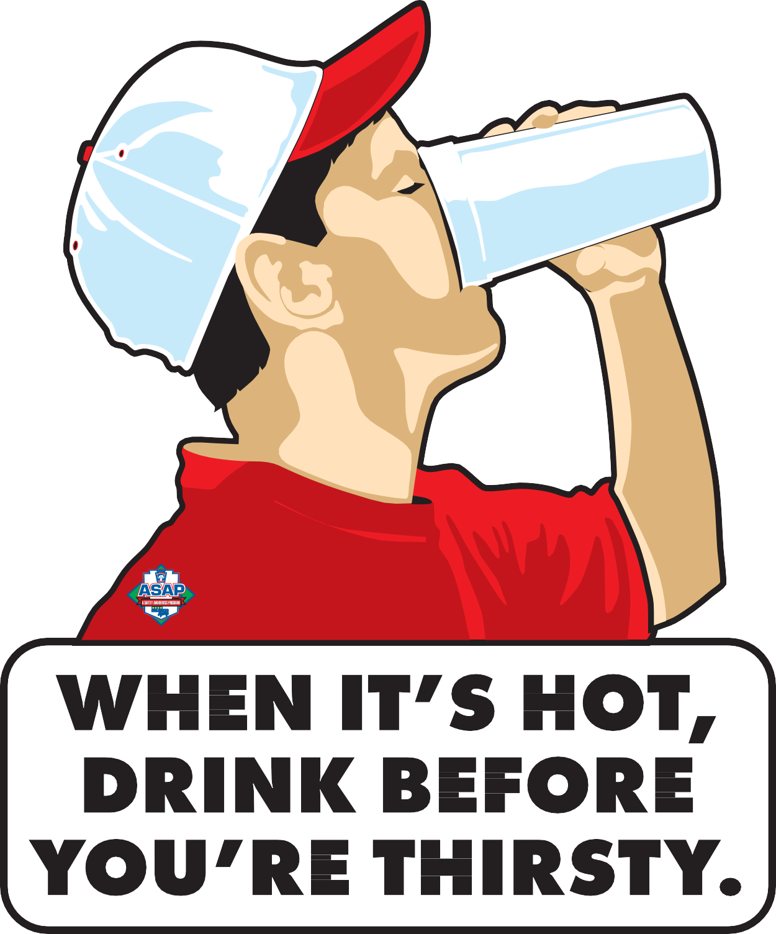
© 1996 Little League Baseball® and Musco Lighting, Inc.

Drinking Guidelines For Hot Day Activities

Before: Drink 8 oz. immediately before exercise During: Drink at least 4 oz. every 20 minutes After: Drink 16 oz. for every pound of weight lost
Dehydration signs: Fatigue, flushed skin, light-headed What to do: Stop exercising, get out of sun, drink Severe signs: Muscle spasms, clumsiness, delirium

Requirement #15: Survey Questions

Questions and Answers will be added once Safety Manual is uploaded to the Data Center and questions are received.

